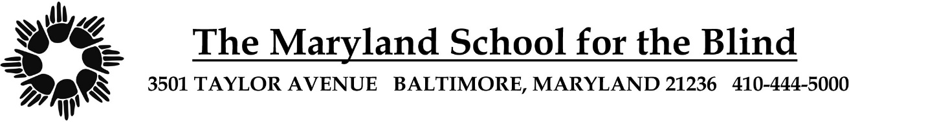

**STUDENT ACCEPTABLE USE POLICY (AUP)**

**SY 2025-26**

**STUDENT:**

1. I understand that my cell phone must stay off and stowed (backpack or locker) during the school day.
2. I understand that I may use my cell phone after 3:00 pm only in designated areas and during times that do not interfere with my programs.
3. I understand that my cell phone cannot be used after bedtime (for residential students only).
4. I will not use any electronic device while walking.
5. I will use appropriate language (no profanity, bullying, or harassing) when using electronic devices.
6. I will use electronic devices for instructional purposes only.
7. I will not change, delete, or damage materials that belong to others.
8. I will not use electronic devices to create, access, download, or print material that shows obscenity, cursing, use of weapons, or violence.
9. I will not share passwords and usernames.
10. I understand that MSB monitors my use of electronic devices and that my privilege for using the devices can be taken away if I do not follow the rules stated above.

________________________________________

Student Signature Date

__________________________________________

Parent/Guardian Signature Date

*More information regarding this policy is available in the MSB Student/Parent Handbook located at: https://www.marylandschoolfortheblind.org/my-msb/msb-families/*