

**LEGISLATION COMMITTEE**

**MARCH 13, 2025 – 3 PM**

**In Attendance:**

Ms. Karen Malinowski, Committee Chair

Ms. Marion Mullauer, Board Chair

Dr. Joanne Waeltermann

Ms. Robin Zimelman

Mr. Scott Wales

Mr. Rob Hair, MSB Superintendent

Ms. Kibian Vazquez, MSB CFO

Ms. Valerie Johnson, MSB Executive Assistant

Mr. John Stierhoff, Venable, LLP

**Absent:**

Mr. Craig Ballew

Delegate Stephanie Smith

Senator Guy Guzzone

**Call to Order:** Ms. Karen Malinowski convened the meeting at 3 pm. A quorum was present.

**Approval of November 20, 2024 Minutes:** Ms. Malinowski made a motion, seconded by Ms. Robin Zimelman, to approve the minutes. A vote was taken and the minutes approved.

**2025 Legislation Advocacy and Strategy:** Mr. Rob Hair and Mr. John Stierhoff discussed the following:

**Governor appointees:** Mr. Hair reported that the following Governor appointees were approved with their terms beginning on July 1, 2025: Mr. Ray Brown, Mr. Lou Smith, Ms. Kati Penney, Delegate Stephanie Smith and Senator Guy Guzzone.

**Legislative Meetings and Strategy:** Mr. Hair reported that, over the past seven years, the strategy has been to restore MSB’s relationships with legislators and develop partnerships with decision makers. This required transparency and open dialogue. By navigating the political environment and showing MSB as a responsible financial steward, MSB is now seen as a trustworthy institution.

|  |  |  |  |
| --- | --- | --- | --- |
| Year | Original Per Pupil* | Reduced Per Pupil | Loss Per Pupil |
| 2026 | $9,226 | $9,063 | $163 |
| 2027 | $9,732 | $9,398 | $334 |
| 2028 | $10,138 | $9,626 | $512 |
| 2029 | $10,564 | $9,866 | $698 |
| 2030 | $11,004 | $10,276 | $728 |

**\*1 pupil = 1 on campus student + ½ unique Outreach Student**

There is a threat to Blueprint funding. With significant budget cuts required to address billions in the state deficit, requesting millions in additional funding would be imprudent and unproductive. Our objective is to maintain the Blueprint foundation formula funding. The proposed decrease in per pupil funding would have a substantial impact on MSB’s funding—particularly in the out years.

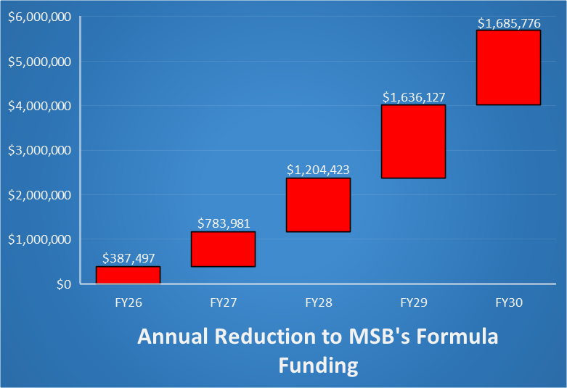

This bar chart was presented demonstrating year-over-year direct funding cuts. In FY26, the reduction starts at $387,497. By FY30, the reductions increase to $1.68 million annually. The numbers demonstrate that this is unsustainable without legislative intervention.

A second chart showed the true impact of the reductions in Blueprint funding. This analysis was benchmarked against revenue that is needed to maintain MSB’s current level of operations—not just reduced Blueprint levels. It reflects the compounding financial impact of per-pupil reductions and outlines adjustments needed to close the gap over time. Strategic modeling was used to determine the minimum funding requirements and potential impacts of not being properly funded.

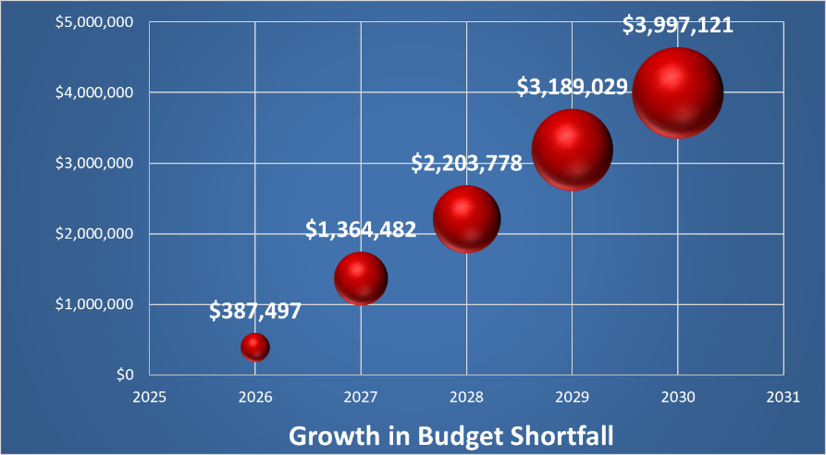

A third interactive line chart showed MSB’s funding needs over time highlighting three key benchmarks: a green line for maintaining full funding and operations, a red line the minimum revenue threshold before austerity measures take effect. The space between the green and red lines are the “safe zone.” An orange line shows the current funding trajectory, currently set if the cuts were to take effect. A graph with numbers and a line

The model allows us to adjust the current funding trajectory in $500,000 increments, demonstrating what level of funding at what year would be needed to keep MSB within the “safe zone.” This could be used to create a strategy for legislative advocacy as well as preparing internal plans for various contingencies.

Mr. Hair discussed several potential austerity measures to address funding shortfalls if needed. These measures include leveraging vacancy savings and freezing selective frozen positions, utilizing fundraising efforts to supplement the budget, and considering requesting Board support for endowment drawdowns as a last resort to cover gaps.

Mr. Hair was asked to clarify per pupil funding and how Outreach students are counted in the formula. He explained that per pupil funding is the amount that the State provides for each student, which forms the basis of the funding formula. Full-time students on campus are counted as one student in the funding formula. Outreach students are counted as half of a student regardless of the number of interactions or “touches” they have with the school. The focus is on unique students, not the frequency of interactions. The funding formula uses a four-year average to smooth out fluctuations in student counts, which helps protect funding levels during years with lower student counts.

Dr. Waeltermann requested that an austerity budget be presented to the Committee. The request emphasized the need for detailed figures and a clear plan to address potential funding shortfalls.

Mr. Hair stated that the team is prepared with numbers and strategies to address funding gaps.  
The plan includes seeking additional funding from the legislature and implementing internal austerity measures if necessary. The strategy involves meeting with budget committee members and advocating for the required funding. He mentioned the legislative session ends on April 7, after which the funding situation will become clearer. The Board will be presented with a complete package of options, including the austerity budget, to make informed decisions regarding the out years when the impact of the Blueprint reductions will impact operations.

Mr. John Stierhoff provided an update on the legislative budget, noting a $3.3 billion shortfall. He stated that the House and Senate are discussing different approaches to addressing the shortfall. The possibility of a special session in the fall to address additional federal cuts is being considered. He commented that the General Assembly is required by the Constitution to have a balanced budget.

**Executive Orders and DEI Committee:** Mr.Hair reported that the school is following state as well as the school’s legal counsel’s guidance on handling immigration officials (ICE) arriving on campus. ICE officers would be processed as a police officer would be. He stated there is no formal DEI committee, no DEI language on the website or print materials. Our language is “equal opportunity employer” which is standard language. What little DEI-related language that existed was in digital documents and has been removed. Legal counsel advised that there is no significant concern, but the school is being cautious.

**Campus Master Plan Update:** Mr. Hair announced that $62 million has been committed by the IAC for the Athletics Facility and front entrance upgrade project. The next steps include finalizing the guaranteed maximum price (GMP) by March 20 and research funding options. The project is projected to take three years, with $10 million committed by the State for FY 26. Different financing options are being explored, including tax-exempt instruments. The goal is to present a comprehensive package of financing options to the Board for consideration, including the possibility of building the pool and delaying the gym.

**Bill Ratchford Outdoor Learning Center Update:** Mr. Hair announced the completion of the project with a total of $55,000 in donations, including donations from Mr. Ratchford’s former legislative colleagues.

**Open Meetings Training and Compliance:** Ms. Mullauer commented that it has come to the Board’s attention that since 2014 MSB falls under the State’s Open Meetings Act statute. She stated that the school's attorney will review the Open Meetings Act requirements with the full Board in an Executive Session at the March 28 meeting. Ms. Malinowski will provide the link for the on-line training for Board members who are interested. Ms. Mullauer commented that the bylaws will be checked against the Open Meetings Act to identify and rectify any non-compliant practices.

**Adjournment:** There being no further business to discuss, Ms. Malinowski adjourned the meeting at 3:54 pm.