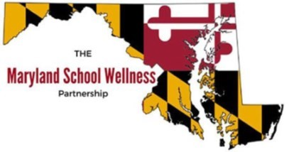
Maryland School For The Blind
MARYLAND WELLNESS POLICIES & PRACTICES PROJECT

The mission of the Maryland Wellness Policies and Practices Project (MWPPP) is to enhance opportunities for healthy eating and physical activity for Maryland students by helping schools and school systems create and implement strong and comprehensive wellness policies.
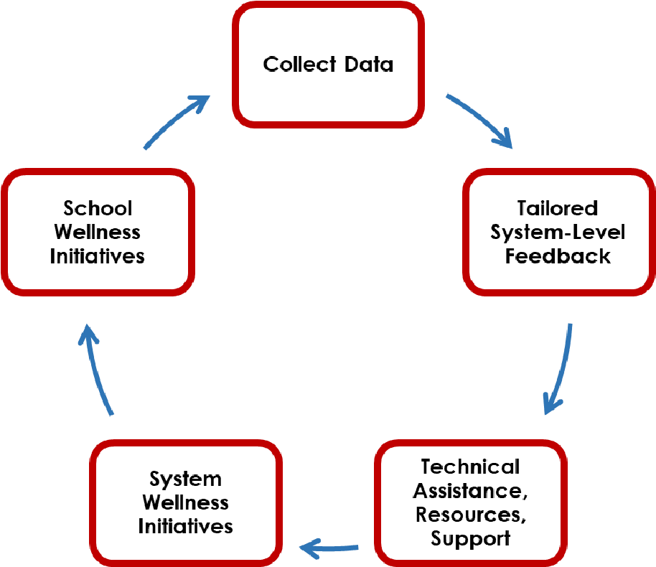
The MWPPP employs a continuous quality improvement model (see the figure on the right) to assess wellness policy implementation in schools through biennial evaluations, system-level recommendations, and technical assistance provision to school systems.
The MWPPP is a statewide initiative and includes the :
- University of Maryland School of Medicine
- Maryland State Department of Education (MSDE)
- Maryland Department of Health
- University of Maryland Extension

FEDERAL WELLNESS POLICY REQUIREMENTS
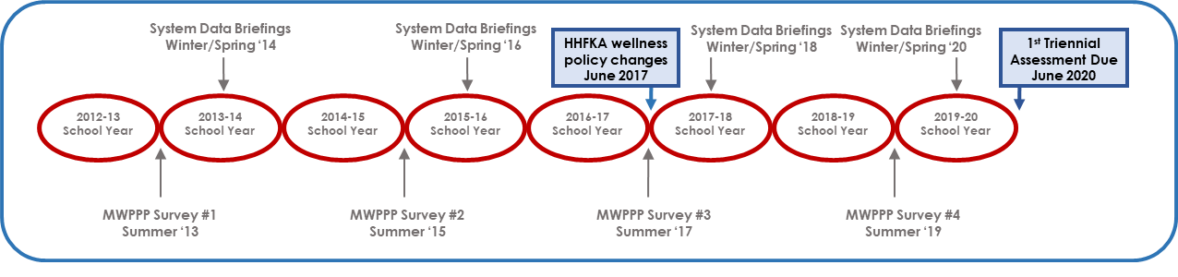
Wellness policies can improve food choices, dietary intake, and physical activity for students and staff. However, to be effective, a wellness policy must be implemented, monitored, and assessed. The Healthy, Hunger-Free Kids Act (HHFKA) of 2010¹ required all Local School Systems participating in federal child nutrition programs to update and expand their written wellness policy by June 2017 and publicly report on school-level wellness policy implementation beginning in June 2020 and every three years thereafter (“the triennial assessment”).

Throughout the report, this icon denotes policies or practices required by the Federal Government

THE MWPPP TIMELINE

The responsibility for developing, implementing, and evaluating a wellness policy is placed at the local level, to address the unique needs of each school. The MWPPP is a resource for school systems to meet the HHFKA provisions. This report provides information on two of the three components of the triennial assessment: [1] comparison with a model wellness policy (Section 1) and [2] reporting on school-level wellness policy compliance (Section 2). For the third triennial assessment component, school systems will report on progress toward meeting goals of their wellness policy. Based on the HHFKA, the written wellness policy and any policy updates must be made available to the public on an annual basis, and all three components of the triennial assessment must be made publicly available by June 30th, 2020. *
*Due to pandemic response, triennial assessments were allowed to be waived until June 30th, 2021. 31 out of 33 school systems have waived reporting until the June 2021 deadline.

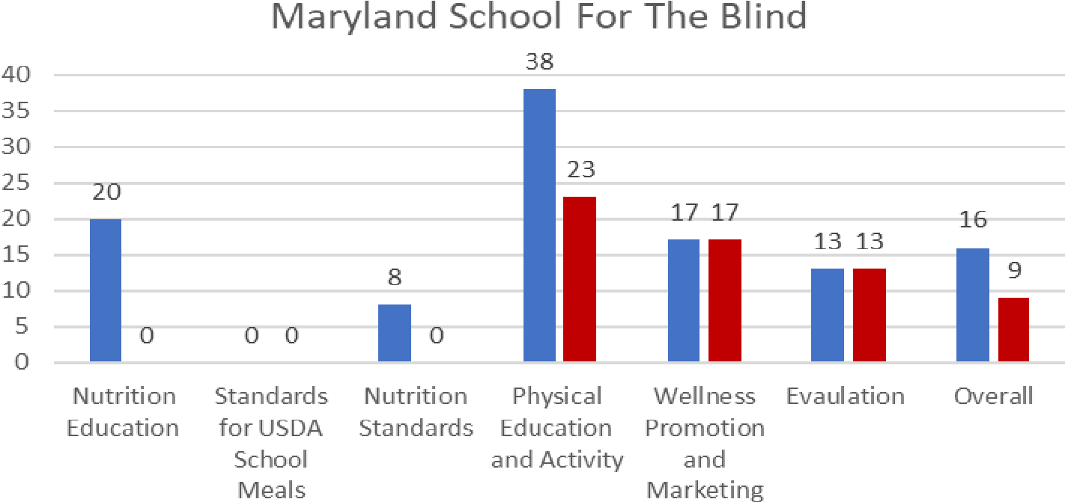
SECTION 1: WRITTEN WELLNESS POLICY SCORING

The Wellness School Assessment Tool
(
WellSAT) scores wellness policy
language.
2

All items in the WellSAT 3.0 reflect current
federal law or best practices.

Scores range from 0 to 100 for both the
strength and comprehensiveness of the
policy language. Strength refers to how
strongly the content is stated.
Comprehensiveness refers to how well
recommended content areas are covered
in the policy.

WellSAT 3.0 evaluates six policy sections:

1.

Nutrition Education

2.

Standards for USDA Child Nutrition
Programs and School Meals

3.

Nutrition Standards for Competitive and
Other Foods and Beverages

4.

Physical Education and Activity

5.

Wellness Promotion and Marketing

6.

Implementation, Evaluation, and
Communication

A tailored WellSAT 3.0
score report will be given
to each Maryland school
system in Spring 2020 to
meet the HHFKA triennial
assessment final rule
requirement #1
(
comparison to a model
policy).

WellSAT 3.0
comprehensiveness and
strength scores for wellness
policies across Maryland
School For The Blind Agency
(
average), overall and for
each of the six policy sections
is shown to the right.

*RESOURCE HIGHLIGHT!* MSDE’s Office of School and Community Nutrition Programs has developed a
Triennial Assessment Guidance and Reporting Tool³ for school systems to prepare
MSDE TRIENNIAL for the first triennial assessment, due by June 30, 2020. This tool provides detailed
ASSESSMENT guidance on what is required for the triennial assessment and contains the
GUIDANCE & reporting framework for submitting the first assessment. In addition to the three triennial assessment requirements, the tool also captures methods for sharing ^{REPORTING TOOL} school wellness information to the public, a HHFKA requirement.
Maryland-specific examples below illustrate weak and strong wellness policy language for new HHFKA wellness policy requirements.
Policy Item | Example Weak Language | Example Strong Language
Food/Beverage  Marketing | Marketing strategies, such as taste tests and signage in the cafeteria, should be used to promote healthy food and beverages throughout the school. | Any foods and beverages marketed or promoted to students on the school campus during the school day, will meet or exceed the “Maryland Nutrition Standards for All Foods Sold in Schools” such that only those foods that comply with or exceed those nutrition standards are permitted to be marketed or promoted to students.
Public Involvement in the Development, Review, and Update of the Policy | Students, parents, and/ or community members are welcome to join wellness committee. | School Wellness Council reviews the District Wellness Policy every three years. Members of the School Health/Wellness Council will represent all school levels and include, but not be limited to: parents and caregivers; students; representatives of the school nutrition program physical education teachers; health education, mental health and social services staff, the general public etc.
Foods Provided but Not  Sold During the School | We will allow one traditional party food during celebrations. | Incentives or awards for student achievement shall be non- food health minded incentives e.g. extra recess, leadership opportunities, brain boost, public acknowledgment of achievements.
SECTION 2: MARYLAND SCHOOL FOR THE BLIND (MSB)-SPECIFIC SCHOOL WELLNESS DATA
Section 2 outlines school-level wellness practices from the MWPPP school survey that either align with HHFKA policy changes or have a clear scientific link to student academic or behavioral outcomes. Additional data are provided to each Agency in Fall 2020 and the full survey is available online.⁴
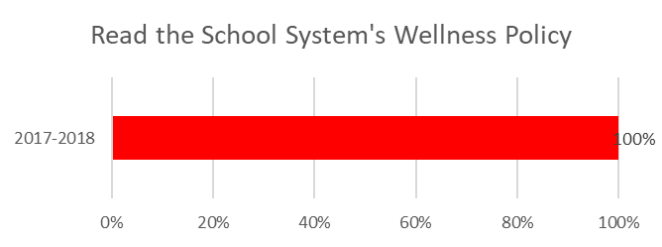
The school survey was administered during both the 2017-2018 and 2018-2019 school years and schools were asked to respond once.
The school survey response rate for the 2017-2018 school year was 100%, with 1 schools completing the survey. 0% of respondents were administrators.
100% of Maryland School For The Blind sites reported having read their school system’s wellness policy,

MARYLAND’S SYSTEM LEVEL RECOMMENDATIONS
Evidence suggests schools that perceive system support are more likely to implement their written wellness policy. Maryland’s10 evidence-based recommendations for school systems to promote wellness policy implementation, originally released in 2010, are built around three themes: Build, Communicate, and Monitor.

Build Communicate Monitor
- Maintain a system-level school 5. Report policy goals to local school 8. Hold regular policy meetings to health council board review current policies
- Identify funding to support policy 6. Communicate system-level wellness 9. Measure semi-annual or annual implementation initiatives to school-level wellness progress in achieving system wellness
councils goals
- Communicate implementation plan to the public 7. Communicate progress in wellness 10. Provide technical assistance for the policy implementation to public evaluation and reporting of policy 4. Train staff to support policy implementation implementation
Throughout the report, this icon denotes Maryland-specific recommendations

SECTION 2A: SCHOOLS’ PERCEPTIONS OF SYSTEM SUPPORT
The MWPPP survey asked Maryland School For The Blind about perceived system-level support for school wellness initiatives.
My Agency... | % Under  Development
Has a school health council to address general health and wellness issues | 100%  ally Ice
Provides technical assistance to schools for evaluating wellness policy implementation | 100%
Provides public updates on the content and implementation of wellness policies | 100%
Has a mechanism in place to encourage the broader school community or public involvement in developing and updating wellness policies | 100%

MARYLAND’S SCHOOL LEVEL RECOMMENDATIONS
Maryland’s 5 evidence-based recommendations for schools to promote wellness policy implementation, originally released in 2013, are built around the same themes as the system recommendations: Build, Communicate, and Monitor.

Build Communicate Monitor
- Establish a school-level wellness team 4. Communicate and promote the 5. Gather and report school-level data and appoint a coordinator importance of healthy eating and on wellness policy implementation
- Develop school wellness goals and physical activities for students, families, an implementation plan connected and the community to school improvement team goals
- Identify resources to implement wellness policy priorities

SECTION 2B: NUTRITION GUIDELINES & ENVIRONMENT
Below we highlight the implementation of some HHFKA nutrition-specific wellness policy practices in Maryland School For The Blind site.
My Agency…. | % Fully In  Place
Does not permit staff to use food/beverages as a reward for academic performance or good behavior | 100%
Assures/Has a designated person that all foods and beverages sold to students during the school day meet the Maryland Nutrition Standards for All Foods Sold in School⁵ | 100%
Makes safe, unflavored, drinking water available throughout the school day at no cost to students | 100%
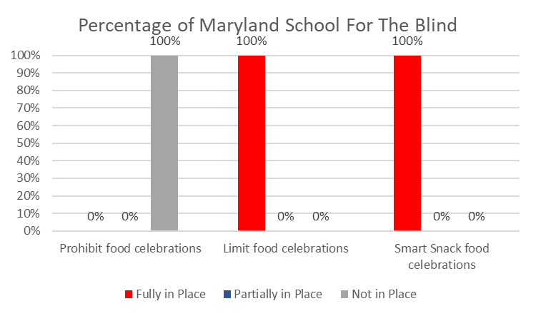

Let’s Celebrate!

Each School System can decide how to address foods/beverages provided
during celebrations in their written wellness policy.

FUNDRAISING & FOOD MARKETING
Federal and Maryland State Law Says: Any food/beverage item sold during the school day (outside of the breakfast or lunch program) must meet Maryland Nutrition Standards for All Foods Sold in Schools.⁵ The State has determined that there are no exempted fundraisers during the school day. This policy is in place from midnight prior to 30 minutes after the end of the official school day without exception.
Federal regulations further mandate that any food or beverage that does not meet the state's standard for Smart Snacks may not be marketed or promoted on campus during the school day.

*Resource highlight!* Information for schools on the Maryland Nutrition Standards for All Foods Sold in
Schools, including fundraisers and marketing, is provided in the “Smart Snacks in Maryland” video.⁶

Federal regulations further mandate that any food or beverage that does not meet the
state's standard for Smart Snacks may not be marketed or promoted on campus during the school day.

My Agency... | % Fully in  Place | %  Partially in Place | % Under  Development
Did not permit the marketing of foods/beverages that do not meet Maryland Nutrition Standards for all foods sold in school/Smart Snacks in Schools standards, throughout the building | 100% | 0% | 0%
Had marketing to promote healthy choices by: displaying visible and readable posters with healthful foods within all service and dining areas | 0% | 100% | 0%
Had marketing to promote healthy choices by: displaying signs that promoted site meals and featured menu items in other areas of the school such as the main office, library or gymnasium | 0% | 0% | 100%

SECTION 2C: PHYSICAL ACTIVITY AND EDUCATION
Providing physical activity during the school day can significantly improve student academic achievement and time in on-task behaviors.⁷ There are multiple ways for children to be active at school, including physical education class, recess, classroom physical activity breaks/integration, and before/after school programs. Physical activity and education specific survey responses for MSB sites over time, are shown below.
My Agency.. | % Fully in  Place | % Partially in Place
Coordinated services related to healthy eating and physical activity In sites | 0% | 100%
Did not permit physical activity to be used as punishment (e.g. making a student run laps, do push-ups) | 100% | 0%
Did not permit physical activity to be withheld as punishment (e.g. taking away recess or ending  PE class early) | 100% | 0%
Provided recess for every grade | 100% | 0%

SECTION 2E: SCHOOL WELLNESS TEAMS
0% of schools had a wellness team.

Wellness teams were not recorded among survey respondents. Compare wellness team performance across Maryland with the MD MWPPP State Data Briefing Report.⁸
MEMBERSHIP

Wellness teams included the following members:

Teacher

(
Non
-
PE/
Health)

PE

Teacher

Administrator

Counselor

Student

Nurse

Health

Teacher

Community
Organization (s)

Food
Service

Parent

Healthy Eating and Physical Activity

WELLNESS TEAM MEETIN
G FREQUENCY

INVOLVING THE PUBLIC

Wellness teams focus on
both healthy eating and
physical activity within
sites.

Wellness team meeting
frequency can vary from
monthly to quarterly.

Wellness teams used a
variety of strategies for
reaching families and
community members

SECTION 2F: EMPLOYEE WELLNESS
Given the focus on employee/staff wellness by many wellness teams, information on staff wellness practices among Maryland School For The Blind sites is listed below. Research shows that staff members who participate in wellness activities experience lower levels of burnout and absenteeism as well as higher levels of job satisfaction and performance.⁹
My Agency... | % Fully  In Place | % Under  Development
Organized and held activities for staff to support and promote healthy eating and physical activity | 100% | 0%
Provided training/education to encourage staff to model healthy eating and physical activity behaviors | 100% | 0%
Promoted healthy eating and physical activity for staff members | 100% | 0%
Encouraged staff members to model physical activity behaviors | 0% | 100%

SECTION 2D: FAMILY AND COMMUNITY INVOLVEMENT
Involvement of the broader school community is an important element of the HHFKA wellness policy changes. The table below shows how MSB sites are involving families and communities in school wellness.
My Agency.. | % Under  Development
Provides opportunities for student input on wellness policy implementation | 100%
Partnered with parents/families or community organizations to support and promote healthy eating and physical activity among students | 100%
SECTION 3: 2020 CALL TO ACTION FOR MARYLAND SCHOOL FOR THE BLIND
Call to Action |  | Steps | Support Data
WRITTEN WELLNESS POLICIES  Update system level written wellness policies to meet federal and state requirements | ◻  ◻  ◻  ◻ | Read your school level wellness policy  Ensure policy aligns with HHFKA  Make wellness policy available to the public  Set wellness goals for the year | The average comprehensiveness score for MSB Wellness policy was 16 (out of a possible 100), indicating that policy language needs to be expanded and strengthened to include all recommended and required components.  100% of school survey respondents reported that they read their system wellness policy
BUILD  Establish school-level wellness teams; appoint coordinators | ◻  ◻ | Support school-based wellness team development and sustainability  Promote evidence-based wellness team practices in schools | Maryland School For The Blind ‘s Wellness Team is under development
COMMUNICATE  Communicate system-level  wellness initiatives to schools | ◻  ◻  ◻ | Make schools aware of wellness policies and the system-level health council  Provide public updates on the content and implementation of wellness policies using multiple communication strategies  Share school-level implementation strategies throughout the system | MSB reported their systems 'school health council to address health and wellness issues is under development
MONITOR  Gather and report schoollevel data on wellness policy initiatives | ◻  ◻ | Provide schools with a reporting tool to measure and report policy implementation  Provide technical assistance to schools for meeting wellness policy regulations | MSB reported that their system to provide schools with technical assistance to evaluate policy implementation is under development.
Notes and References
- Healthy Hunger-Free Kids Act of 2010. Pub. L. No 111-296, 124 Stat. 3183, 13 December 2010.
- “About the WellSAT.” WellSAT, Rudd Center. 2018. www.wellsat.org/about_the_WellSAT.aspx.
- Maryland Local School Wellness Policy Triennial Assessment Guidance and Reporting Tool: this tool will be made available in Spring 2020. http://www.marylandpublicschools.org/ programs/SchoolandCommunityNutrition
- Unless otherwise specified, this report only presents survey responses that are “fully in place” in comparison to all other responses (“partially in place,” “under development,” “not in place,” and “don’t know”). Additional information on MWPPP data collection (as well as the full 2018-19 survey) will be made available on www.marylandschoolwellness.org in Spring 2020.
- Maryland Nutrition Standards for All Foods Sold in Schools. http://marylandpublicschools.org/programs/Documents/Nutrition MDNutritionStandardsforAllFoodsSoldJune2018 policychart.pdf
- Smart Snacks in Maryland video. http://www.marylandpublicschools.org/programs/SchoolandCommunityNutrition/Pages/TTA
- Alvarez-Bueno, C. et al.(2017). Academic achievement and physical activity: A meta-analysis. Pediatrics, 140(6).
- MD MWPPP Data Briefing Report. 2020 http://www.marylandschoolwellness.org/Projects/Maryland-Wellness-Policies-and-Practices-Project/
- LeCheminant et al. (2015). Health behaviors and work-related outcomes among school employees. American Journal of Health Behavior, 39(3), 345–351.
For more information, please visit www.marylandschoolwellness.org and click the “Tools & Resources” tab on the right side of the page.
Primary funding support:
(1) This project has been funded at least in part with Federal funds from the U.S. Department of Agriculture. The contents of this publication do not necessarily reflect the view or policies of the U.S. Department of Agriculture, nor does mention of trade names, commercial products, or organizations imply endorsement by the U.S. Government. (2) Centers for Disease Control and Prevention (CDC), Cooperative Agreement #2B01OT009025 through the Maryland Department of Health, Center for Chronic Disease Prevention and Control; (3) CDC, Cooperative Agreement #5U58DP003497; (4) CDC, Prevention Research Centers Program Cooperative Agreement #U48 DP001929 and Special Interest Project #12-062 (Nutrition Obesity Policy Research Evaluation Network, NOPREN) with the University of Maryland Prevention Research Center.
The views expressed in written materials and publications do not necessarily reflect the official policies of the Centers for Disease Control and Prevention, the Department of Health and Human Services, the Maryland Department of Health, or the Maryland State Department of Education nor does the mention of trade names, commercial practices, or organizations imply endorsement by the U.S. Government.
Non-Discrimination Statement: MSDE and USDA are equal opportunity providers.
Contact Information:
Erin Hager, PhD (University of Maryland School of Medicine) ehager@som.umaryland.edu
Leslie Sessom Parks, MSW (Maryland State Department of Education) leslie.sessomparks@maryland.gov
This report was prepared by Garrett Sijgers, BS, Jasmia Shropshire, BS, Erin Hager, PhD, Megan Lopes, MPH, Leslie Sessom Parks, MSW, Marla Caplon, RD, LD, Chrissa Carlson, MS, Jason
Semanoff, MS, Sara Schofield Booker, MPH, RD, Lea Jaspers, MA, Ann Pulling Kuhn PhD, and the Maryland School Wellness Partnership. January 2020

