M.D. & Parent

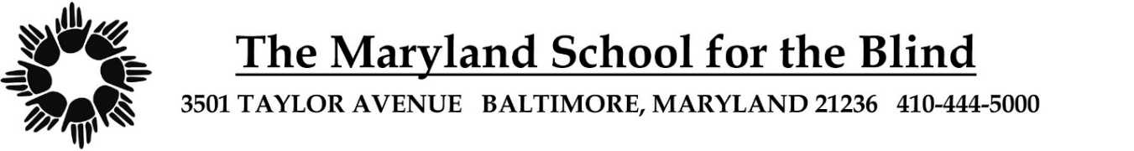
PHYSICAL ACTIVITY FORM
(Physical Education and Recreation Permission
Required for All Students)
School Year 2023-2024

Student Name: Date of Birth:

Adapted Physical Education - All students have Adapted Physical Education for low vision/blindness as part of their curriculum. Please indicate below if there are any medical reasons for exception.
Adapted Physical Education

(Example: Age appropriate skill development, fitness & activities) No exception

Exception:

Adapted Aquatics: goggles required for students with unilateral vision. No exception

Exception:

Adapted Recreation (Example: Skiing, Bowling, Horseback Riding) No exception

Exception:

Physician Signature Date Physician Phone Number

Physician Printed Name

Parent/Guardian Signature Date

Parent/Guardian Printed Name

PB/LB/cic:4/13/23

