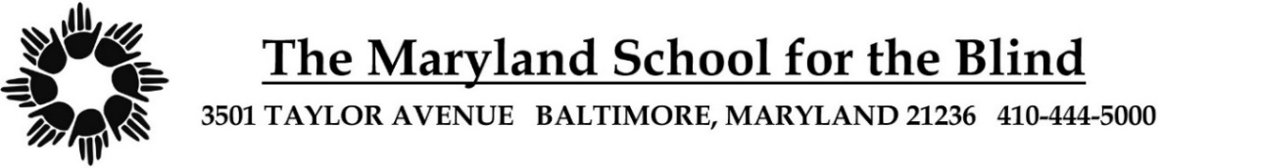
Parent
HEALTH UPDATE FORM
Health Center - School Year 2023-2024

Student Name: Date of Birth:

Please Answer All Questions or Mark N/A
Are there any NEW medical issues since last Fall? Yes No
If yes, please describe:

What medications does your child take at home? Please list meds taken at home and school.
Include dosage, frequency, and times.

Please list current allergies. Are there any new allergies since last year?

Medication Allergies:

Food Allergies:

Environmental Allergies:

No Allergy to Medicine, Food or Environment

This information will be up to date as of the date this form is signed. I will keep the
Health Center informed of any changes in the health of my child to the best of my abilities.

Signature of Parent/Guardian Date

Printed Name of Parent/Guardian

PB/LB/cic:4/13/23

