23  FEB | Adapted Lacrosse Clinic | 6:30-8  PM
Mr. Marty Delaney and Parkville Adapted Lacrosse are coming to MSB to put on a lacrosse clinic. All MSB students, including Outreach students, ages 7-21 are welcome to attend. For more information please contact Timothy Taylor Email-timothyt@mdschblind.org
Phone #- 410-444-5000 ext. 1312
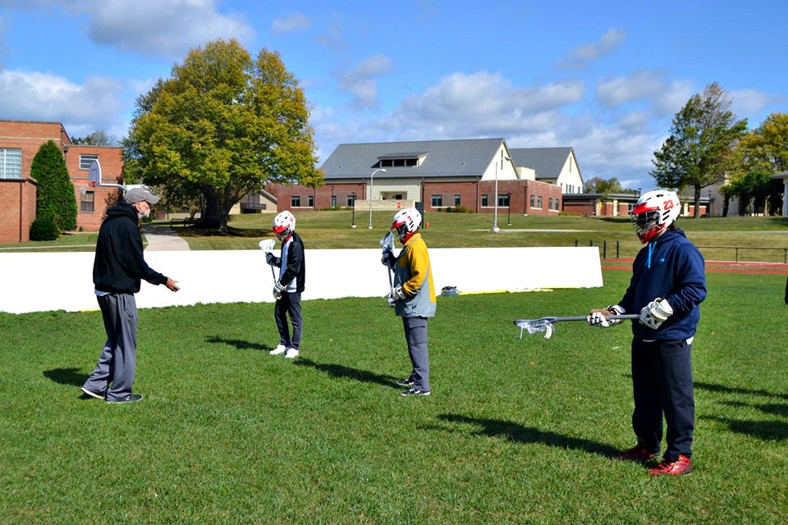
Figure 1 Lacrosse coach teaching three athletes about lacrosse in an outdoor setting.
3501 Taylor Ave, Baltimore, MD 21236
MSB Knefely Gymnassium

