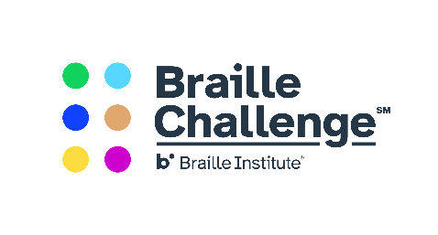

FOR IMMEDIATE RELEASE Media Contact:
June 11, 2020 Dotty Raynor, 410.319.5722
dottyr@mdschblind.org

2020 National Braille Challenge Finalists Announced
Baltimore, MD - Four students who competed in the 2020 Maryland Regional Braille Challenge are among the top 50 qualifiers for the National Braille Challenge. Julia Stockberger from Perry Hall, MD, Sujan Dukal from Perry Hall, MD, Meredith Day from Finksburg, MD and Naomi-Jean Mills from Woodbridge, VA will be competing in the national competition later this month.
The Braille Challenge®, a program of the Braille Institute, is the only academic competition for blind or visually impaired students in the United States and Canada.This two-stage contest is designed to motivate blind students to emphasize their study of braille, while rewarding their success with fun-filled, but challenging, local and national events.
Students complete preliminary testing across the country from January through March in hopes of qualifying for the top 50 spots available in the national competition and the opportunity to compete against the top blind students from across the United States and Canada.
According to Jacqueline Otwell, Maryland Braille Challenge Coordinator, "The Braille Challenge is a rigorous competition. In my opinion, Julia, Meredith, Sujan, and Noami-Jean represent some of the best and brightest students in the United States and Canada. I am so proud of our National Qualifiers and wish them the best as they compete at the national level."
The Maryland Regional Braille Challenge, which was hosted by The Maryland School for the Blind (MSB) and the Maryland State Department of Education (MSDE), was held on February 8. The school has hosted this event for the past eleven years.
The national competition, which is typically held in Los Angeles, California annually in June, will be held remotely this year. In a statement from the Braille Institute, “Since 2000, the Braille Challenge has been a celebration promoting braille literacy, advocacy, friendship, partnership and festivities. This year, due to the COVID-19 situation, our tradition of a 2-day event at the University of Southern California will look a little different. Despite these changes, we aim to capture the essence of a traditional Braille Challenge Finals experience with a remote program, continuing our aim of promoting braille literacy across North America.”
For more information contact Dotty Raynor, 410-319-5722 or dottyr@mdschblind.org
###

About The Maryland School for the Blind
As a statewide resource center, MSB provides outreach, educational and residential services for students to reach their fullest potential by preparing them to be as successful, independent, and well-rounded contributing members of their communities as possible. Annually MSB serves approximately 1,200 students identified in Maryland who are blind or visually impaired from birth to age 21. For more information visit www.marylandschoolfortheblind.org

About Braille Institute of America

Braille Institute of America is a nonprofit organization whose mission is to eliminate barriers to a fulfilling life caused by blindness and severe sight loss. It serves tens of thousands of people of all ages each year through an array of integrated educational, social and recreational programs and services designed to help people with vision loss lead enriched and fulfilling lives. Braille Institute's Los Angeles headquarters are located at 741 N Vermont Ave, Los Angeles. For additional information, please visit www.braillechallenge.org. or www.brailleinstitute.org.

