How to Make Your Own Light Box

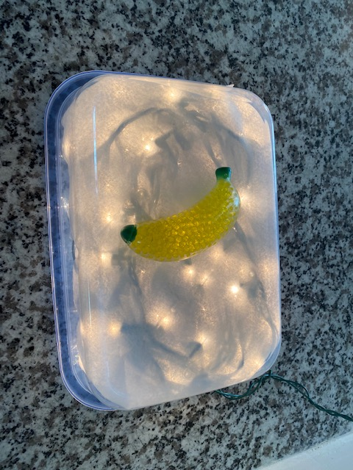

Materials:

Large, shallow plastic container with lid (I purchased mine at the Dollar Tree. It says it holds 14.6 cups.)

White holiday lights, string/”fairy” lights, battery-operated tea lights (make sure the lights do NOT have a flickering effect)

Plain white felt, fabric, an old t-shirt, or piece of paper

Box cutter, Exacto knife

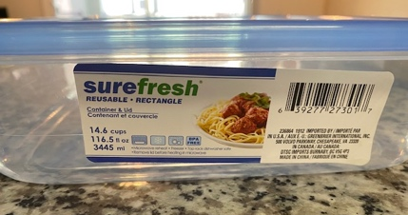

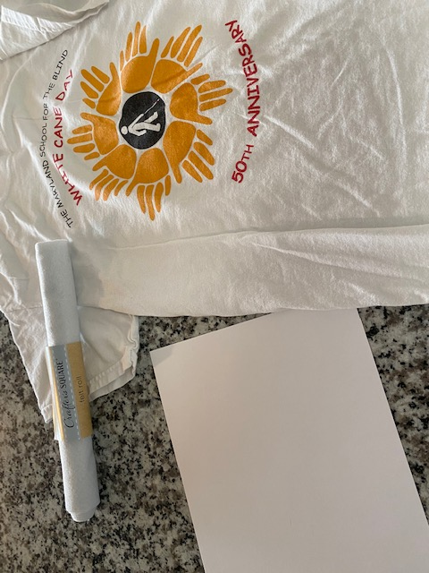

Instructions:

- Cut a small square opening out of the side of the container (if you are using lights that need to be plugged into the wall).

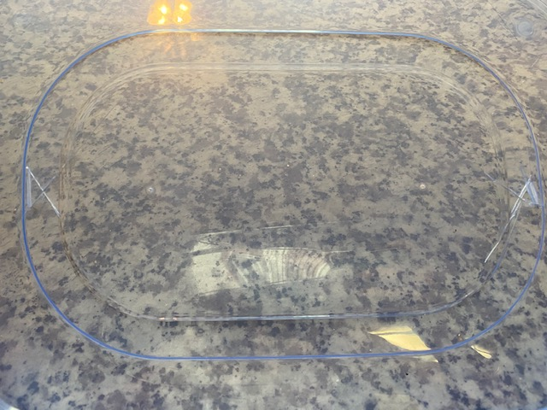

- Cut ventilation holes in the lid.

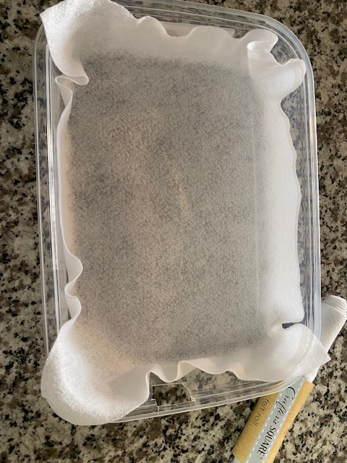

- Place a single layer of the plain white felt, fabric, t-shirt, or piece of paper in the bottom of the container.

- Put the lights in the container (turn on if using battery-operated lights). String plug through hole cut out of the side of the container (if using string lights).

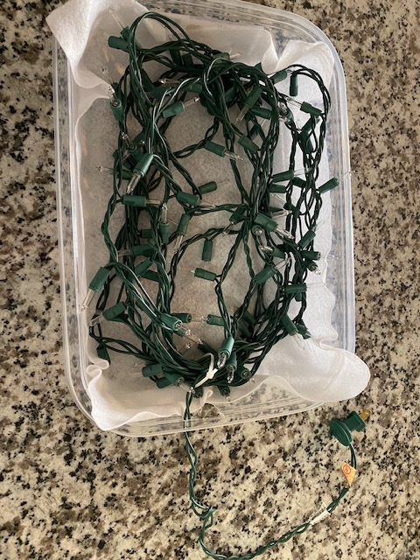

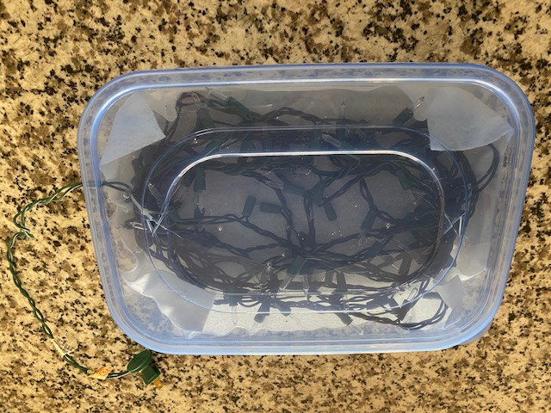
- Put the lid on.

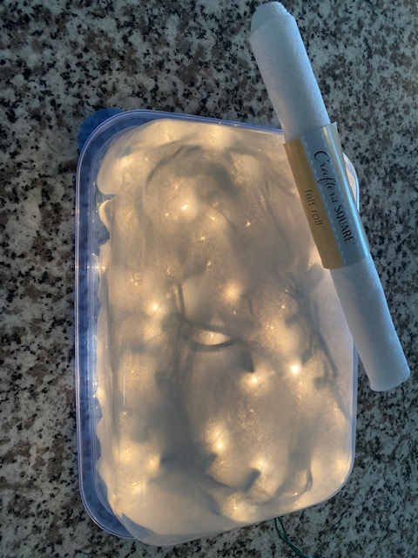
- Turn the container upside down so the lid is flat against the table. Plug in the lights (if necessary).

IMPORTANT NOTES:
- The lights can get hot in the container so be sure to monitor the temperature of the container. Cut more ventilation holes in the side of the container if needed. Take the lid off to help it cool down after use.
- Be careful when cutting the container and lid; the plastic can crack.
- If using battery-operated tea lights, be sure they do NOT have a flickering “candle” effect.
- Dim the lights in the room when using the light box to help draw your child’s attention to the materials even more.

