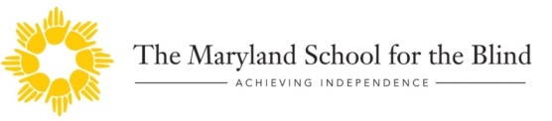
THE MARYLAND SCHOOL FOR THE BLIND &
THE LIBRARY FOR THE BLIND AND
PHYSICALLY HANDICAPPED PRESENT OUR SPRING
SATURDAY, MARCH 28TH, 2020
9:00 AM – 1:00 PM
The MDB (Multiple Disabilities Building) Motor Room
3501 Taylor Ave. – Baltimore, MD 21236
This is a family event for students that are visually impaired or blind preparing for the transition from high school.
Job, Career and Secondary Education resources available from DORS (Division of Rehabilitation Services), The Disabilities Department at UMBC, MSB’s Career Education and Transition Programs and other community organizations.
It’s never too early to start thinking about your future. Join us for a day packed with opportunities for networking and creating a game plan for your future. It’s time to make those connections for the next steps.
To Register go to: https://docs.google.com/forms/d/1nNjcl_wiclH_C1nDjS0bRAPZIYhKGtQ-Osh4rPAsN6o/edit

