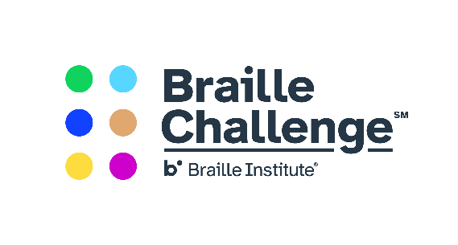
Blast off into an exciting adventure written by YOU!

The 2020 Maryland Regional Braille Challenge invite you to participate in their creative writing contest about an adventure in space! This topic coincides with our theme and our give away of braille copies of the book Mission to Cataria, featuring Oskar the Blind and cat and his pal Klaus’s adventure in outer space. You do not have to participate in the Braille Challenge to enter but you must be a Braille reader. Winners will be notified in advance of the Maryland Regional Braille Challenge.

In your story be sure to include:
- How you would help aliens learn about braille
- A tactile picture or description of the alien
- What you would take
- Ways your journey is accessible

Stories will be judged on creativity and will be broken in the following age groups:
- K-2
- 3-5
- 6-12

Prizes will be awarded to winners in each category. Please send your stories in braille either in hard copy or electronic formats. E-mail electronic formats to kerrym@mdschblind.org or Maryland School for the Blind, Outreach Department, 3501 Taylor Avenue, Baltimore, MD 21236. Any questions? Contact Jackie Otwell at jacquelineo@mdschblind.org. Stories due by January 10, 2020.

Be creative and have fun! We can’t wait to read your stories!

