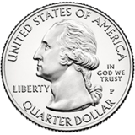

QUARTER AUCTION

Saturday November 16th, 2019

1 PM

All Bids
25¢
Paddles
2 for $5

Doors Open at 12PM

Maryland School for the Blind
Knefely Gymnasium
3501 Taylor Avenue Baltimore, MD 21236

To Benefit
MSB’S Class of 2020

Bring your friends and join us for some fun!
Start saving those quarters now.

Gift Cards Pampered Chef Paparazzi

Money Bags Tupperware

Thirty-One Mary’s Purses
And More…

Tickets Contact: Karin 410.446.0015

