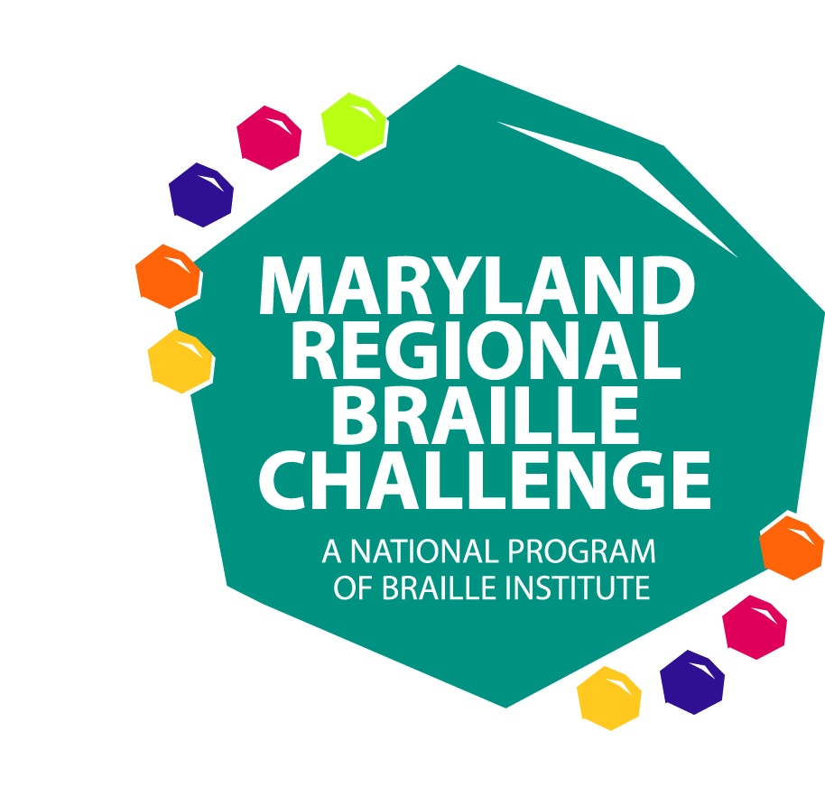

MARYLAND REGIONAL BRAILLE CHALLENGE

Save the Date for the 2020 Maryland Regional Braille Challenge!

The Maryland Regional Braille Challenge will be held on Saturday, February 8, 2020 (Snow Date: February 22, 2020). The theme is going to be out of this world!

Special Congratulations to our National Qualifier – Noa Hottin and Julia Stockburger

What is the Braille Challenge? The Braille Challenge is a reading and writing competition held at Maryland School for the Blind. Braille Challenge contest categories include reading comprehension, writing speed and accuracy, proofreading, spelling, and reading tactile charts and graphs. As students take tests parents/guardians attend workshops. At the end of the day families can visit vendors and participate in a variety of activities. All participants receive a prize! Students’ scores are submitted to the National Braille Institute to see if they are among 1 of 50 students in the United States and Canada to qualify for the National Braille Challenge in California. Visit the link Braille Challenge to learn more.

Registration will be available soon and hope to see you there!

Any questions? E-mail Jackie Otwell, Coordinator of the Maryland Regional Braille Challenge at jacquelineo@mdschblind.org

Follow the Maryland Regional Braille Challenge on Twitter @mdbrlchallenge #mdbc20

