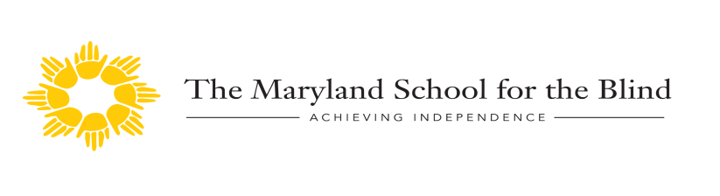

Outreach Low Vision Services 2019-2020

Functional Vision Consultations and Assessments

We continue to offer functional vision consultations and assessments in the student’s home school or natural environment to address their ability to access age and grade level educational and leisure materials. Areas assessed include but are not limited to color vision, near and distance visual acuities, functional visual perceptual skills, response to magnification and assessment of personal characteristics and environmental factors that may impact functional use of vision. If visual perceptual concerns are suggested during the functional vision assessment, assessment of visual perceptual skills using standardized assessment materials is available with results generated through consultation from MSB occupational therapists. There is no charge for first and second consult visits per student. An hourly rate will be applied on the third visit. The functional vision consultations and assessments are provided from Tuesday through Friday.

Materials should be adapted only to the extent necessary for efficient learning. If regular materials can be used in conjunction with environment adaptations or low vision devices, such an approach is preferable to using specialized materials.

M.M. Stratton: JVIB, Jan. 1990 (84) 3-5

Clinical Low Vision Evaluation

The Outreach Low Vision Clinic provides clinics at MSB and regional clinics upon request. The on-campus clinics are offered on a Friday from September through May with appointments at 9:00 a.m., 10:00 a.m. and 11:00 a.m. The evaluations include Saman Bhatti, O.D. low vision optometrist who has provided our services since the 2012-2013 school year, Susan Vanderhoff, LCSW/C and Sharon Whited, CLVT. Service representatives of other therapies may be available and assessments requested by other therapists can be arranged prior to or following the clinic evaluation. Regional low vision clinics are provided at a location decided upon by the county for up to four students and include the low vision optometrist and low vision specialist.

The focus of the clinical low vision evaluations is to identify strategies and devices to maximize the students’ ability to use their vision to complete daily activities. The evaluation includes assessment of color vision, contrast sensitivity, near and far distance visual acuities, refraction, assessment of visual field and lighting including the use of sunwear, visual perceptual screening and introduction to strategies and optical and non-optical devices to enhance their functional use of vision. The student, parents and teacher are active participants in the clinic evaluation.

Dilated optometric examinations are available to students who have not received a dilated examination within a year of their low vision evaluation to ensure that the student is wearing their best refractive correction. Distance vision will be addressed following dilation and best correction and near vision will be addressed through follow-up in the Low Vision Clinic or at the student’s school with the TVI.

Low Vision Clinics
September 20, 2019
October 11, 2019
November 8, 2019
December 13, 2019
January 17, 2020
February 14, 2020
March 13, 2020
April 3, 2020
May 15, 2020

Regional Optometric Examinations

Regional optometric examinations are available upon request for up to four students at a time. The optometric examinations include cycloplegic dilation and include evaluation of visual abilities and the health of the eye including the appearance of the eyes, anterior chamber, lens, eye pressures, and refraction to determine the need for glasses and examination of the back of the eye. If concerns are noted the student is referred to their private physician for more extensive examination. Regional optometric examinations are provided on a Friday at a location decided upon by the county and include the low vision optometrist and low vision specialist.

Scheduling

To schedule a regional or on-campus clinical evaluation, optometric examination or functional vision consultation or assessment, contact Sharon Whited, Low Vision Specialist at 410.444.5000, x1276 or 1.800.400.4915 or sharonw@mdschblind.org.

For information about additional services available through the Outreach Department at MSB, contact Ruth Ann Hynson, Director of Statewide Outreach Vision Services at x1726, 410.319.5726 or ruthh@mdschblind.org. For information about events and activities offered through Outreach Services, contact Kerry Michael, Administrative Assistant at x1249 or kerrym@mdschblind.org.

Mission
As a statewide resource center, the School provides outreach, educational and residential services for students to reach their fullest potential by preparing them to be as successful, independent, and well-rounded contributing members of their communities as much as possible.

https://www.marylandschoolfortheblind.org/

