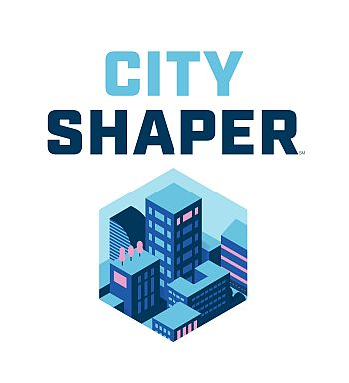
First LEGO League 2019
This year’s challenge is building a better world…

What if you could build a better world? Where would you begin?
More than ever, we must come together to innovate and solve problems. In FIRST®, you are part of a thriving community brimming with inspiration, creativity, and hope for a stronger, more sustainable future - one that's built better together. You have the power to help the cities, towns, and places you call home reach new heights. With the support of the FIRST community, this is your opportunity to lead our future forward - and up.
Build a better world with MSB Outreach First LEGO League team, 180 Optimum! The team will code with Quorum which is an evidence-based accessible programming language. It will also incorporate large print, braille, and other strategies into all aspects of the team, which emphasizes Core Values, Research, and Robotics. The team will compete against other teams in our region!

Interested students should register by September 13th. Students should have a strong ability in math, science, and technology. Experience using digital applications like Google Classroom preferred.

Practices will be held twice a month, on September 21, October 5, & 19, November 2 & 16, and December 7, & 14, with extra practices leading up to competition. Students will be expected to attend every meeting and complete homework. The team will be made up of 10 students, ages 9 – 14 and 2 junior coaches ages 15+ so make sure to REGISTER SOON!

Register here!

