MSB February Parent Informational Webinar
Tuesday, February 26th, 2019
11:30 AM – 12:30 PM
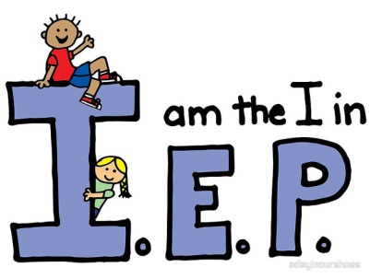

Project HEAL (Health, Education, Advocacy, and Law) at Kennedy Krieger Institute
Presenters, Alyssa Navarrete, Esq. and Mallory Finn, Esq. from Project HEAL, a community-based program of the Maryland Center for the Developmental Disabilities (MCDD) at Kennedy Krieger Institute, will provide a comprehensive overview of special education
law and the IEP process.

*Please register prior this event by following the link below;
https://zoom.us/meeting/register/fbf979e5c63af9428c34be5db4a05ad8
Renee Kirby, Parent Coordinator, The Maryland School for the Blind, reneek@mdschblind.org

