Braille Challenge
Art Challenge
Calling all Braille Readers and/or Braille Appreciators…
Here is your chance to show your support of Braille and the Regional Braille Challenge by creating wearable art in the form of a
T-shirt design !
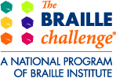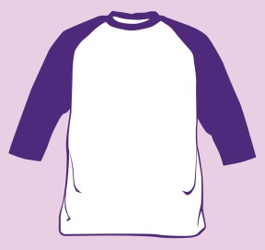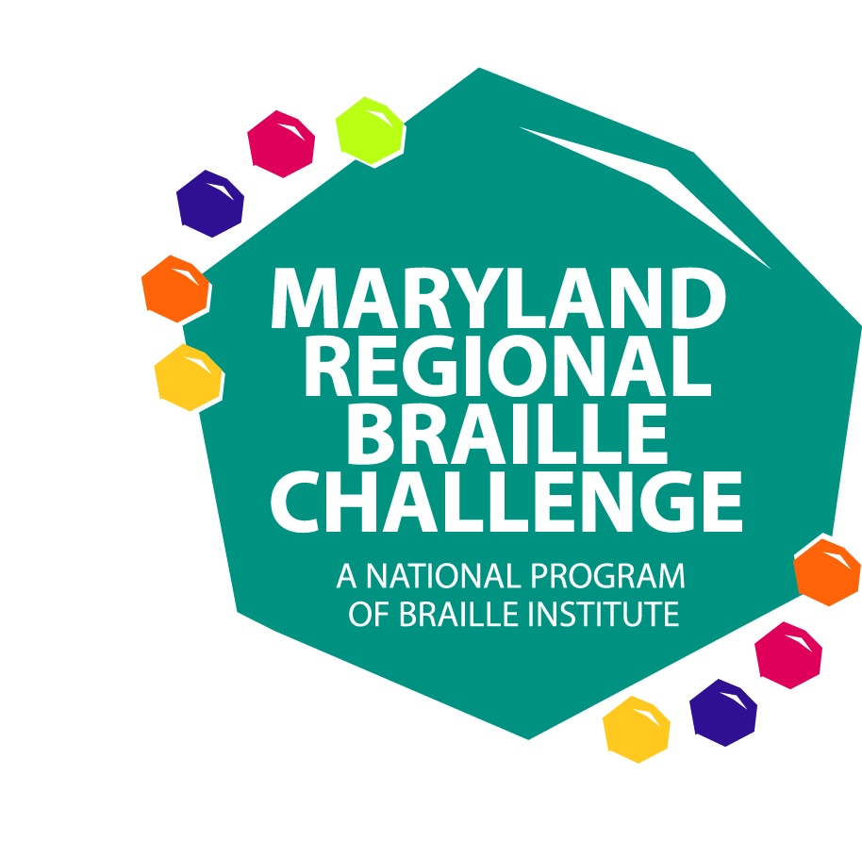

On Saturday, February 9th we will be celebrating the 10th Anniversary of the Maryland Regional Braille Challenge. In addition, the Braille institute will celebrate it’s 100th Anniversary in 2019. The Braille Challenge is an academic competition for Braille readers grades 1-12 to show their literacy abilities in five categories of fundamental Braille skills; reading comprehension, spelling, speed and accuracy, proofreading and charts and graphs.
Won’t it be AWESOME knowing that all Braille Challenge competitors are decked out in your wearable artwork?
How to enter the 10th Anniversary of the
MD Regional Braille Challenge
Art Competition:
- Students in grades K– 12 create a design within the parameters of the attached paper that represents what Braille means to you. This design can be a literal or abstract design. Have fun with it!!
- Your design can be up to 4 different colors, plus the white background of the t-shirt.
- Make sure you sign your artwork and include your name, age, grade, school and title of your artwork on the paper attached.
- Place your original artwork and the info page into an envelope large enough to accommodate braille paper 11-1/2”x11”. Seal envelope and send in the mail by December 17th to:

MSB Outreach Art Contest
Renee Kirby
3501 Taylor Avenue
Baltimore, MD 21236

The winner will be chosen and notified by January 25th along with all other entries.
A runner up and honorable mention will also be chosen. Regardless of your participation in the Braille Challenge, all 3 winners will be given a t-shirt with the chosen design.
*Your artwork will not be returned, so please snap a picture prior to sending it to the above address.

NAME_________________________________________
AGE___________________
GRADE_________________
SCHOOL________________________________________
TITLE OF ARTWORK_______________________________________

________________________________________________

