 **MSB Reaching Out Newsletter**

**September/October 2018**



###### Hello,

Welcome to a new school year!!!

This time of year has always brought me mixed emotions…sadness in letting go of long summer days spent with my children while the excitement of embarking on new beginnings and what that may bring for the year ahead!

I’m guessing most of us face very similar emotions at the start of a new school year, however, for students with special needs, a new school year can also bring a fear of change.

Transitioning from one grade to the next may cause anxiety, panic, and meltdowns, especially for students who have difficulty expressing their feelings and emotions.  Parents can help prepare their children with a few simple steps to ease some stress and ensure a positive experience for their child.  Remember: each child’s needs are very individual and special in their own way.  What works for one child may not work for another.  These tips might inspire other ways to help your child transition into the new academic year smoothly.

**Contact the Teacher Prior to or at the Start of School**

Email your concerns and questions to the teacher.  You can also include any pertinent information about your child that you feel may help make the initial introduction. By knowing information about your child, the teacher will have an easier time getting him or her acclimated to school.

**Communication is Key**

Just as you would like a heads up with changes to your work schedule or other issues that arise, giving teachers information about home life may make a world of difference in your child’s success during the school day. Sending a quick morning email or text (if you have exchanged phone #’s) to your child’s teacher about issues concerning sleep, eating, morning meltdowns, etc., could make or break the school day.

**Review Your Child’s Individualized Education Plan**

Your child’s Individual Education Plan, or IEP, is a legal document that maps out an educational plan for the year.  Parents should always keep the document handy and highlight important information to refer to through the year.  Keep the most recent IEP in an expandable file labeled with the current school year, along with other important documents you may need; recent doctor reports and/or assessments.

The important information on an IEP is:

- Date of annual review

- Contact person

- Time and setting of related services such as TVI, O&M, speech, occupational and/or physical therapy

- Goals and objectives

- Accommodations and modifications, including those for state testing

- Statement of transition for older students 

**Use Similar/Same Terminology**

Confer with your child’s teacher as to what phrases and terminology he or she uses in the classroom when referring to toileting and mealtime, in particular. Try using these terms and phrases as much as possible in your home environment create less of a gap and more consistency in routines. You may even see less of a struggle when accomplishing other tasks at home.

**Avoid Over-Scheduling Your Child**

Less is more, especially when planning our children’s extracurricular activities, according to studies done on this subject. “The more time kids have in less structured activities, the more self-directed they are and, also, the reverse is true: The more time kids spend in structured activities, the less able they are to use executive function” (controlling one’s behavior). This was taken from study author, Yuko Munakata, professor of psychology and neuroscience at the University of Colorado, Boulder.

**Create a School Station in Your Home**

Mornings can be hectic for everyone!  Picking out clothes, finding shoes, and retrieving lost backpacks at the last minute can lead to frustration and stress that can cause a child with special needs to melt down. This negative feeling can easily set the tone for the rest of the school day.  Organization reduces stress and helps your child start the day happy. Of course, planning the night before is always helpful.  In addition, create an area in your home for school supplies.  This area can be for hooks or shelves for backpacks, lunchboxes, important papers and other items your child needs.  This space is also great for a family calendar or a “To Do” list to keep track of everyone’s activities.  You can even create a makeshift message center for you and your kids to communicate by writing on the glass of a picture frame using some dry erase markers!

**Do Not Panic!**

Children sense anxiety and worry in others.  They will mimic your words and actions.  Stay calm, positive, and refrain from negativity. One thing every parent can do for their child, whether they have a disability or not, is to make school special.  Celebrate this new milestone with them and embrace every moment together.  Commend success and support failure.  School will certainly bring highs and lows, but if your child knows you are a team, success is inevitable!

I hope that these suggestions can assist in a smooth transition to the 2018/2019 school year!!

Until next time,

**Renee**

**MSB’s TECCH for Success Summer Program 2018**

By, Cody Laplante, Technology Instructor

This one week camp enabled blind and visually impaired students gain an understanding about the importance of Expanded Core Curriculum in their educational and daily life while learning essential technology skills.

The elementary session of TECCH for success focused on using Technology to gain skills in areas of the Expanded Core Curriculum. The students completed a 3-part project in which they completed a list of tools they use to read and write for part one, wrote a list of things they might be looking for in a job for part two, such as lighting, noise level, and coworkers, and wrote a paragraph describing what they would like to do when they grow up for part 3. Students also took a field trip to White Marsh Mall to examine different jobs that they might want to apply for in high school.

The Middle School/High School session of TECCH for success focused on using Technology to complete a Four Phase project investigating what jobs they would want to apply for. Throughout the camp, students earned stipends for each phase of the project they completed, and were able to spend those stipends on lunch during our Field Trip to White Marsh Mall. Through the completion of the project, students found out how to get to their job using Google Maps, how much money they will make and how much money they may need to spend on monthly expenses using spreadsheet formulas. At the end of the week, students gave a presentation on all of the information they collected throughout the week, and left camp with a plan to get a job in the near future.

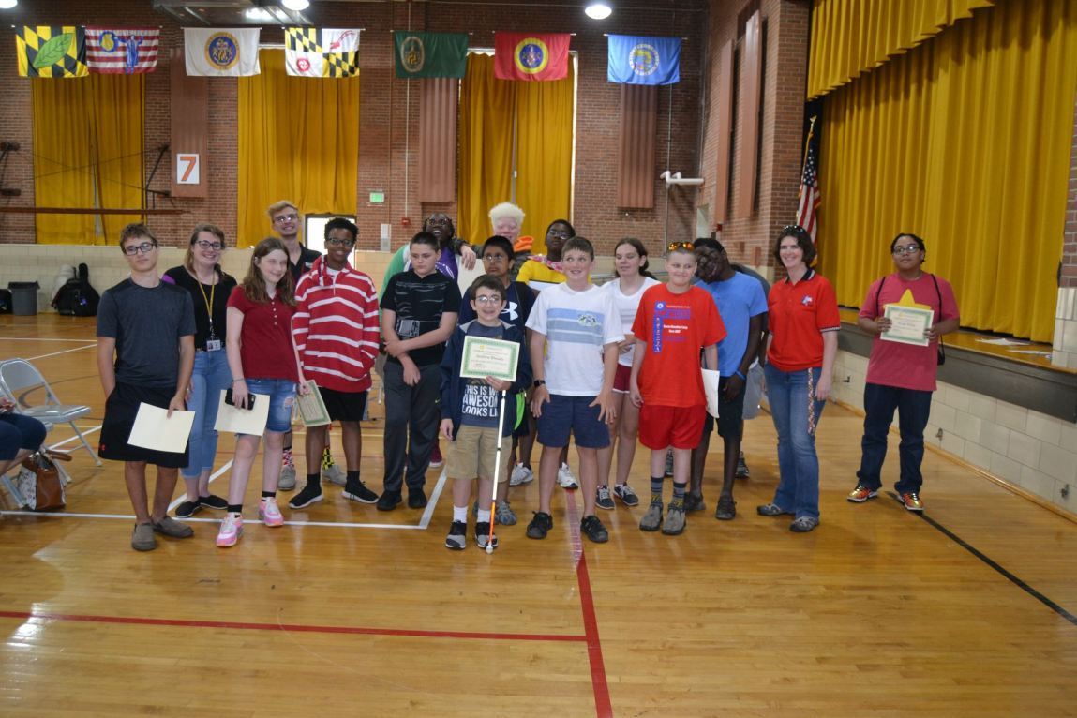

A group shot on the last day of TECCH for Success Summer Program

*-------------------------------------------------------------------------------------*

***MSB Camp Abilities at Camp Merrick 2018***

For the first time in 16 years, MSB was able to partner with Lions Camp Merrick in beautiful Nanjemoy, MD to offer a camp experience that emphasizes outdoor sports like fishing, canoeing, swimming, rock wall climbing, obstacle course, hiking and even archery. Students stay in cabins and enjoy a real camp experience with arts and crafts and campfires with s’mores. Many thanks to the local Lions clubs and private donors who helped to fund campers! We also continue to offer Camp Abilities at MSB which focuses on organized individual and team sports like beep ball, goal ball, blind soccer, track and field, and judo. Follow Camp Abilities on Facebook @MSBCampAbilities.

***Snapshots from MSB Camp Abilities at Camp Merrick 2018…***

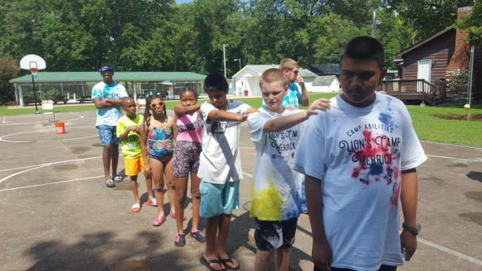 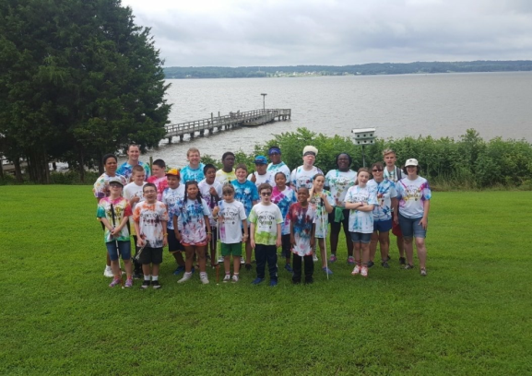

***Campers preparing for group travel Group shot overlooking the Bay***

*-------------------------------------------------------------------------------------------------------------*

***MSB MISLE Summer Program***

For the 3rd year, we offered the Mastering Independence through Living Experiences (MISLE), a program provided in partnership with DORS through Pre-Employment Transition Services (Pre-ETS) funding. This is for students 16 and older who need to work on work readiness skills and daily living skills. Students are given the opportunity to work in various on campus and off campus job sites with job coaching. They are paid a stipend for their work which they can then use to work on budgeting skills and making appropriate decisions on spending. They live in our Independent Living Houses during the 4 week program to learn how to manage a household as well as self-care and organizational skills.

**\***Look for information on MSB’s 2019 Summer Programs sometime in January!

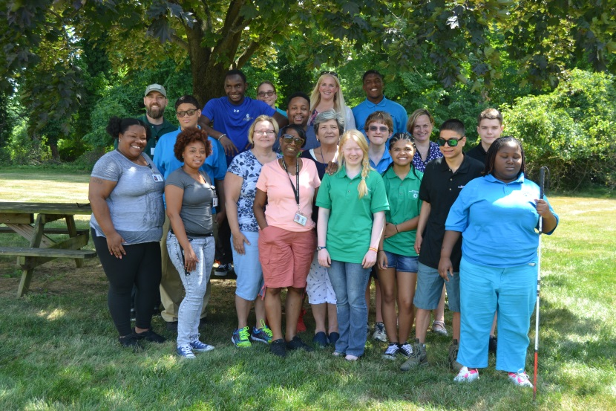

MISLE campers and staff pose for a group picture

----------------------------------------------------------------------------

 ***Upcoming Events*** 

* **First LEGO League 2018**



Blast off with MSB Outreach First LEGO League team, 180 Optimum! The team will incorporate large print, braille, and other strategies into all aspects of the team, which emphasizes Core Values, Research, and Robotics. The team will compete against other teams in our region! Interested students should register by September 19th. Students should have a strong ability in math, science, and technology. Experience using digital applications like Google Classroom preferred.

Practices will be held twice a month, on September 22 & 29, October 20 & 27, November 3 & 17, and December 1, 8, & 15, with extra practices leading up to competition. Students will be expected to attend every meeting and complete homework. The team will be made up of 10 students, ages 9 – 14, and 2 junior coaches ages 15+, so make sure to REGISTER SOON!

* **Informational Webinar**

Join us for the 1st Webinar of the 2018/2019 school year

**Monday, Oct. 22nd, 2018 / 11:30 – 12:30**

***“Know Your Child’s Legal Rights When Navigating Their IEP”***

Presenter; **Leslie Margolis,** Managing Attorney,

Disability Rights Maryland

**Please visit <https://zoom.us> and register using the URL below prior to the event.

**Registration URL:** <https://zoom.us/meeting/register/792ff2d1c636c906cde7dc3c8da9331e>

* Save the Date So….You Can Boogie on Down to the 2019 Maryland Regional Braille Challenge!

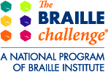 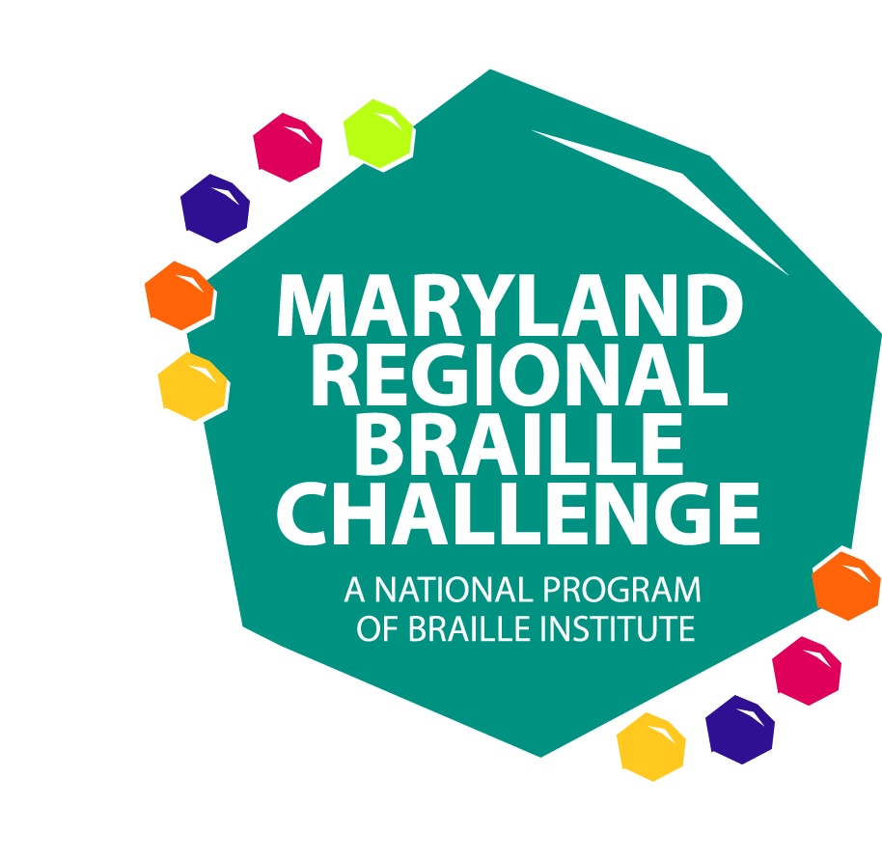

The Maryland Regional Braille Challenge will be held on Saturday, February 9, 2019 (Snow Date: February 23, 2019). We will have a disco theme to celebrate the 10th Anniversary of the Maryland Regional Braille Challenge.

Special Congratulations to our 5 National Qualifiers - Noah Hottin, Noami-Jean Mills, Meredith Day, Yael Kore, Khloe DeLeon-Talbert.

What is the Braille Challenge? The Braille Challenge is a reading and writing competition held at Maryland School for the Blind. Braille Challenge contest categories include reading comprehension, writing speed and accuracy, proofreading, spelling, and reading tactile charts and graphs. As students take tests parents/guardians attend workshops. At the end of the day families can visit vendors and participate in a variety of activities. All participants receive a prize! Students’ scores are submitted to the National Braille Institute to see if they are among 1 of 50 students in the United States and Canada to qualify for the National Braille Challenge in California. If you’d like to learn more visit the following website: <http://www.brailleinstitute.org/braille-challenge-homepage.html>.

Registration will be available soon and hope to see you there!

Any questions? E-mail Jackie Otwell, Coordinator of the Maryland Regional Braille Challenge at [jacquelineo@mdschblind.org](mailto:jacquelineo@mdschblind.org)

***If you have any questions about any of our programs or are in need of resources for your child or would like to be removed from our emailing list, please contact:***

***Renee Kirby***

***Parent Coordinator / The Maryland School for the Blind***

***3501 Taylor Avenue / Baltimore, MD 21236***

[***reneek@mdschblind.org***](mailto:reneek@mdschblind.org) ***or 410-444-5000 ext. 1489***