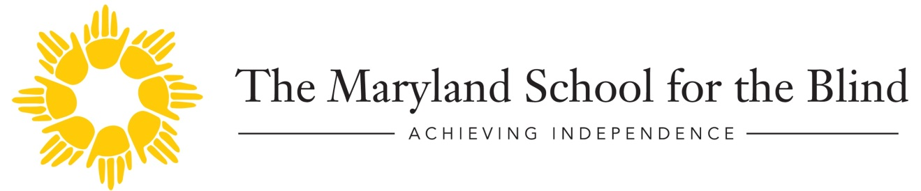
MSB Outreach Charges Summary
Effective July 1, 2018

Evaluations:
There will be a charge for all individual evaluations, which include the written report and follow-up IEP meeting.
Hourly
rate

Psychology $100
Education $85
Learning Media Assessment $85
Therapy/Related Service $85
Functional Vision $85
Assistive Technology $85
Social work $85

Consult Services:
In-state students, there will be no charge for first and second consult visits. The hourly rate will be applied on the third visit.
Out-of-state students: Hourly rate applies for all consults.

Direct Instruction
Orientation and Mobility is the only available service at this time.
In-state students: Charges for hourly rates are already in place through contracts.
Out-of-state students: Hourly rates apply.

Ophthalmology Low Vision Clinics (held monthly)
In-state students: No Charge
Out-of-state students: Hourly rates apply.

Preadmission services
In-state students: No charge
Out-of-state: Hourly rates apply.

Social work Services
There will be a charge for individual counseling sessions at the hourly rate. No charge for after school group programs held at MSB.

