 **MSB Reaching Out Newsletter**

**March/April 2018**



Hello,

How fitting it is as we are looking forward to and prepping our lives for all the changes moving from Winter to Spring , many families are also in preparation for a significant transition, that of their teenage child, transitioning from high school to college and/or a job.

On Saturday, March 10th MSB had the pleasure of offering a day focused solely on the transition process for visually impaired/blind teens and young adults. Our Transition Conference, “What Every Parent Needs to Know About the Transition Process” was held on the MSB campus.

The day began with the keynote speaker, Veronica Lewis, college student & blogger presenting on the college application process, accessible apps, accommodations, self-advocacy and her many experiences to date, including the process of transferring to a more accommodating college.

Veronica, a very articulate young lady does not have a problem making light of, and at times, poking fun at herself. She has a way of taking her experiences and presenting them on her blog, veroniiiica.com to assist other visually impaired young adults with trouble shooting and obstacles they may encounter, Topics range from “Ten Weird Things I Brought to College” to “Ten Tech Skills Every College Student Needs”. Veronica has a way with words to directly connect her experiences and insight with her readers.

After lunch the focus diverted to a Q & A with a panel, which consisted of a combination of professionals and college students. The panel participants, Melissa, Maurice, Chris, Jess and Ashley were able to share similar experiences as Veronica, as well as answer questions and concerns of the parents and transitioning teens. They were all very committed in making sure parents and students left the event with more awareness of what to expect in the coming years in preparing for the next step(s).

Many thanks to all who that participated in making this event a great success and we look forward to bringing our families more events that enlighten, connect and encourage networking, all of which are incredibly important to the success of our children and their future.

Below are some pictures from our March conference.

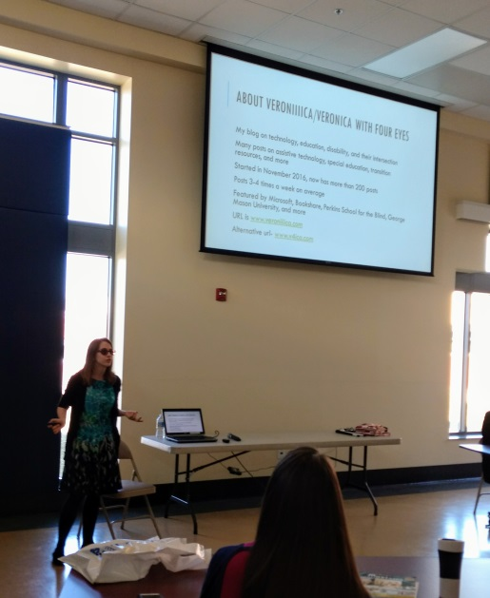 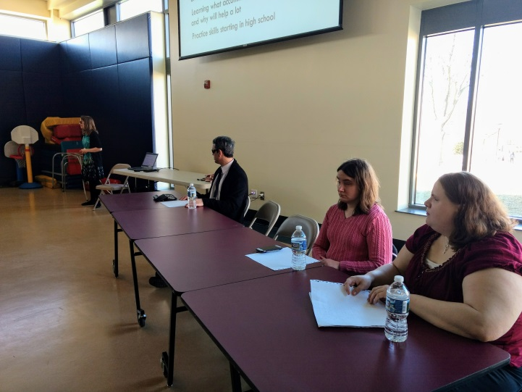

Veronica Lewis presenting her Power Point. Three of our five panel members, Maurice, Jess and Melissa.

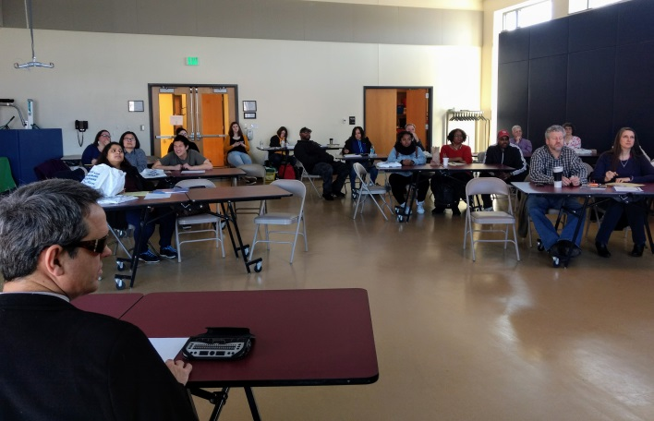

A great turn-out for a day full of wonderful information.

Please check our website, themarylandschoolfortheblind.org for upcoming events.

Until next time,

**Renee**

 ***Upcoming Events***

**Informational Parent Webinars;**

* **Tuesday, April 24th – 11:30 – 12:30pm**

***“Inclusive and Effective Listening Strategies”***

Presenter; **Tracee Ford,** Director of **Quality Assurance Community**

**Mediation, Maryland**

**Registration URL:**

<https://zoom.us/meeting/register/c1eba97bf50284244ac87b605f06faf5>

* **Tuesday, May 22nd – 11:30 -12:30pm**

***“What Parents Need to Know When Navigating Through Laws for Their Visually Impaired or Blind Child”***

Presenter; **Leslie Margolis,** Managing Attorney, **Disability Rights, Maryland**

**Registration URL:** <https://zoom.us/meeting/register/2263be263b45436d7510d14dfea9e911>

* **Using Portable Devices to Improve Accessibility**

**May 18th, 2018 – The Maryland School for the Blind**

Presented by; **Frank Irzyk** and **Dr. Josh Irzyk**

As iOS devices (iPads, iPhones, and iPods) and PC’s are used more and more to provide reading materials in digital text and braille, Daisy, and audio formats, there are a number of paths (and pitfalls) to preparing and delivering materials in formats that students can use. This presentation explores how to prepare materials, select appropriate applications for preparation and presentation, and for getting materials into students' devices. A variety of apps, programs, and options will be demonstrated.

*\*For more information, contact Kerry Michael,* [*KerryM@mdschblind.org*](mailto:KerryM@mdschblind.org)

**The Maryland School for the Blind Summer Programs:**

* **M.I.S.L.E. Summer Institute**

*(Mastering Independence Skills Through Living Experiences)*

**July 9th—August 3rd, 2018**

Research shows that post-secondary success for students with visual impairment can be significantly impacted by lack of training and experience in several areas, including organization, work experience, social skills and mobility. A work based, residential *(Monday-Friday)* program for students with visual impairments ages 14-21 years of age, M.I.S.L.E. is designed specifically to provide intensive instruction in all of these skills and more. Taught by highly qualified teachers and staff trained in the field of blindness.

**Participants will:**

* Work in community based jobs while earning pay.
* Gain more knowledge about employment expectations by visiting various work sites and participating in mock interviews.
* Learn daily living skills necessary for independence.
* Work on social/emotional skills necessary for college, work and lasting connections with peers.
* Engage in activities to build self-advocacy skills.

For Additional Information contact:

**Dareen Barrios 410-444-5000 ext. 1203 or dareenb@mdschblind.org**

Participants must be **Pre-ETS** approved through **DORS.**

(http://dors.maryland.gov/crps/Pages/Pre-ETS.aspx)

Registration and all Health Forms must be returned **May 25, 2018.**

* **TECCH For Success:**

A one week camp for visually impaired students to gain understanding about the importance of the Expanded Core Curriculum in their education and life while learning essential technology skills..

**Elementary Week: July 9 – 13, 2018**

**Middle/High Week: July 23 – 27, 2018**

* **Camp Abilities at MSB:**

A one week overnight sports education camp for youth ages 9 – 17 who are blind and visually impaired on **The Maryland School for the Blind**’s campus.

Cost: $150/ *Scholarships may be available*

**Swimming, Goalball, Beep Baseball, Soccer, Judo, Track and Field, Fitness Activities, and Camp Fires**

**July 16 – 20, 2018**

To register go to: www.marylandschoolfortheblind.org/current-events/outreach-events/ and click 2018 Registration Form .

* **Camp Abilities at Lion’s Camp Merrick:**

A one week overnight outdoor education camp for youth ages 9 – 17 who are blind and visually impaired on the beautiful **Potomac River in Nanjemoy, Maryland.**

Cost: $550 / *Scholarships are available*

**Swimming, Canoeing , Archery, Fishing, Rock Climbing, Crafts, Hikes, and Camp Fires**

**July 29 – August 2, 2018**

To register go to: www.marylandschoolfortheblind.org/current-events/outreach-events/ and click 2018 Registration Form.

*Email if you have any questions at: matthewm@mdschblind.org



**MSB Camp Abilities 2017 group picture.**

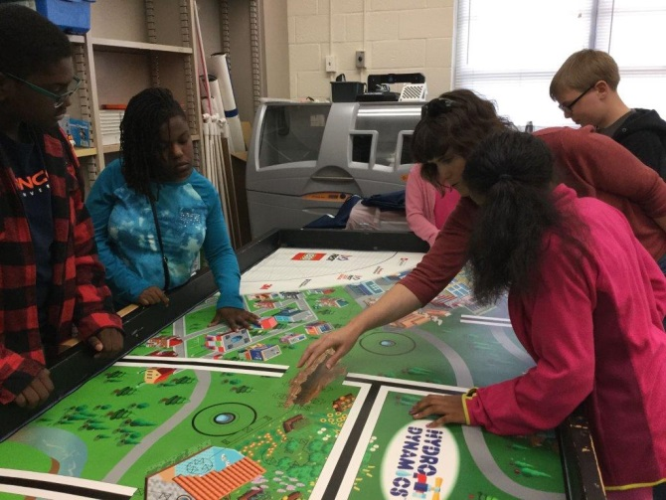 

**Ms. Fugate instructing students in Lego Robotics. Students cooking in M.I.S.L.E .**

***If you have any questions about any of our programs or are in need of resources for your child or would like to be removed from our emailing list, please contact:***

***Renee Kirby***

***Parent Coordinator/Maryland School for the Blind***

***3501 Taylor Avenue / Baltimore, MD 21236***

[***reneek@mdschblind.org***](mailto:reneek@mdschblind.org) ***or 410-444-5000 ext. 1489***