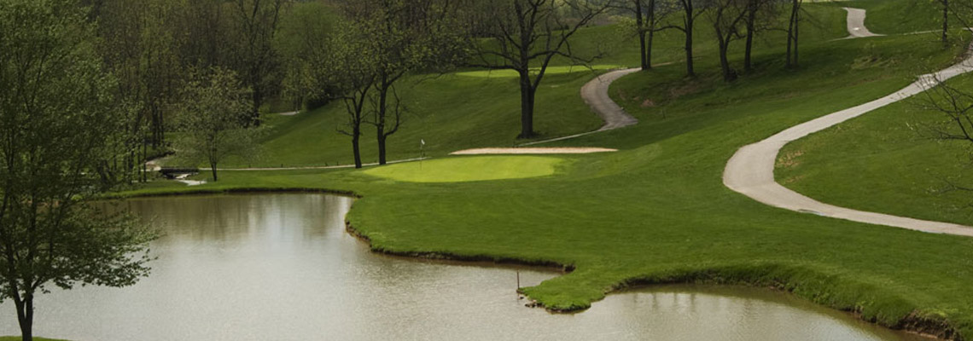
The 4th Annual Robert Lewis Charity Golf Tournament
Held at Oakmont Green Golf Course
Benefitting The Radio Reading Network of Maryland
Monday, June 25, 2018
Shotgun start at 8 A.M.
$85 per golfer

Entry fee includes golf, cart, raffle ticket, prizes for closest to the pin on par 3’s, longest drive, all you can eat buffet (hamburgers, hot dogs, potato salad, fruit salad, chips, pretzels, draft beer, soda, & water)
Get a hole in one at a specified hole & win a
New Car from Norris Ford

Hole sponsorship available for $100
Come out for a great time and a great cause!
We hope to see you there!

To register or for more information please contact Mike Seidel at mikeseidel@verizon.net or (443) 271 – 5988
For more information on the Radio Reading Network of Maryland visit www.radioreadingnetwork.org

