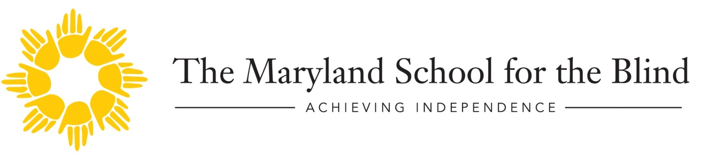
MSB Reaching Out Newsletter
January/February 2018
Hello,
Welcome back!
I hope everyone is getting settled into their routines and staying warm…..brrrrr!
In honor of acknowledging January as Braille Literacy Month, I wanted share a few interesting facts in reference to Braille, according to Jasmine Hall for the NCHPAD (National Center on Health, Physical Activity and Disability) blog;
Six-dot Braille cells have 63 possible combinations
Each cell consists of two dots across and three dots down. A through J sit in the top two rows, K through T include the last, and U through Z add the last two dots to the first five letters. W, however, plays by its own rules owing to the fact that the original French included no such letter.
There are three different “grades” of Braille
Every grade represents a different skill level, with 1 being best for those just starting to learn Braille and 3 for the more familiar. Basic letters and punctuation characterize the first, while the second builds off of that to include contractions – making it the most common version found in public. Once a person hits Grade 3 Braille, he or she can learn the shorthand for personal use, such as lists and notes, rather than more formalized literature.

“Braille for feet” exists
In order for businesses to meet standards set by the Americans with Disabilities Act, Tilco Vanguard developed a veritable “Braille for feet” that assists the visually impaired in knowing the boundaries of dangerous areas. Technically referred to as “truncated domes,” these bright yellow strips spell out a universal message in order to keep store and restaurant patrons safe.
Most legally blind children in the United States do not use Braille resources
Shockingly enough, 34% of the 59,341 legally blind American children (defined by the American Printing House for the Blind as between the ages of 0 and 21) are considered non-readers. That comprises the majority, by the way. Nine percent stick with Braille; 27% are capable of reading visually; 8% get their lessons done as auditory readers; the last 22% qualify as pre-readers.
Visually impaired readers who learned on Braille have a lower unemployment rate than their print counterparts
Earlier studies noted that visually impaired persons who first learned to read using the Braille system hold a 44% unemployment rate. By contrast, those more accustomed to print media —
or incapable of reading Braille, as it were —
sat at a staggering 77%.
..with that being said, The MD State Department of Education along with The Maryland School for the Blind will once again be hosting the annual Maryland Regional Braille Challenge on February 3, 2018. Registered braille-reading students grades prekindergarten through Grade 12 will participate in this very unique reading and writing contest.
Throughout the day, there will be activities/workshops for parents as well. Keynote speaker, Kristen Smedley, author of “Thriving Blind” will be presenting alongside several other presenters, focusing on such topics as Integrating Braille into Independent Living Skills and Hands on Experience with JAWS for Parents.
Please look for the results and awards given in our March issue.
Until then, happy reading,
Renee

Upcoming Events

Informational Parent Webinars;
January 30th, 2018 – 11:30-12:30
Topic: “Quality Assessments – The Key to Literacy”
Presented by: Michelle Horseman, M. Ed/Teacher of the Visually Impaired
Link to join webinar: https://zoom.us/j/580590652

February 27th, 2018 – 11:30- 12:30
Topic: “What is Cortical Visual Impairment (CVI) & How Does it Affect my Child’s Vision?”
Presented by: Sharon Whited, MSB Outreach Low Vision Specialist
Link to join webinar: https://zoom.us/j/219677706

G.R.I.T.S. in the Kitchen (Newly added 2nd Section)
Topics will include labeling, organizing, storage, knife skills, and more. Classes will culminate in a picnic-style lunch for family and friends!
Who: Any student who is visually impaired ages 12-17
Where: The Maryland School for the Blind- 3501 Taylor Ave, Baltimore, MD 21236
When: February 24th, March 10th, April 21st, May 19th and June 2nd from 10:00 am – 2:00 pm
SIGN UP HERE: https://goo.gl/forms/FCSP7NZ2NzmrZcWt2

Savage Race- Team MSB!
May 5th, 2018 (With additional practice dates)
The Savage Race is a 7 mile obstacle course that consists of 25 challenging obstacles….and LOTS OF MUD!!
Athletes who apply must attend practices! Practices will be held 2 times each month starting in February. (Athletes who live too far to make it to a practice must complete a workout program designed for them by the coaches).
Who: Blind or Visually Impaired Students who demonstrate a level of commitment and fitness to complete the growling course. Athletes must be ages 13-17
Where: Meet at MSB- Event is in KENNEDYVILLE, MD
When: MAY 5th *See event details for practice dates*
Deadline to sign up: January 31st, 2018

SIGN UP HERE: https://goo.gl/forms/THddgn4010wLufSY2

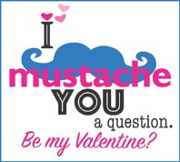 Looking for Braille Valentines?...Check out www.nbp.org
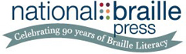

If you have any questions about any of our programs or are in need of resources for your child or would like to be removed from our emailing list, please contact:
Renee Kirby, Parent Coordinator
Maryland School for the Blind
3501 Taylor Avenue/Baltimore, MD 21236
reneek@mdschblind.org or 410-444-5000 ext. 1489

