Transition Tuesdays
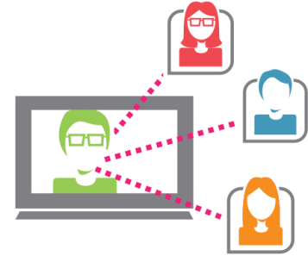
Figure 1 A person on a computer screen connecting with other people.
No need to leave the comfort of your home or office! Participate via your computer with Maryland School for the Blind Outreach as we explore transition in a monthly, informative, free webinar focusing on the transition process and resources available for your student with a visual impairment.

Second Transition Tuesday:
Tuesday, February 21st, 2017
11:30am – 12:30pm
Melissa Riccobono, President of MD Parents of Blind Children (MDPOBC), National Federation of the Blind (NFB) of MD
“Parenting Tips for Teaching Body Awareness and Safety
to Your Visually Impaired Child”
Please go to http://www.ustream.tv/channel/maryland-school-for-the-blind

