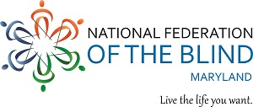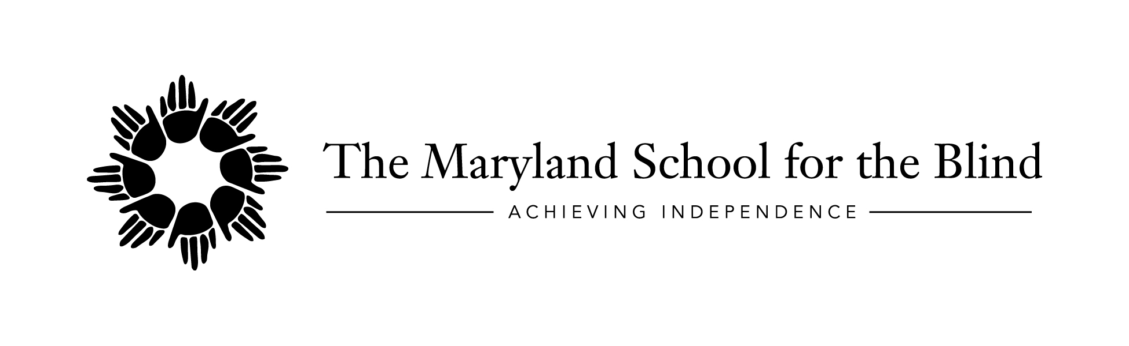
SAVE THE DATE
October 19 – 20, 2017
Braille Literacy in the 21st Century
Location: The National Federation of the Blind, Jernigan Institute
200 East Wells Street, Baltimore, MD 21230
Come celebrate the 25th anniversary of the Maryland Literacy Rights in Education Act and hear about the progress of braille instruction in Maryland as well as nationally! Jointly sponsored by NFB and MSB, the conference will feature national and local speakers presenting on a variety of topics including:
Exploring the Landscape of Braille Literacy
Integrating the Use of Print/Braille into Life Experience
Quality Assessments: The Key to Literacy
Promoting Early Literacy Skills
Integrating Braille for Dual Media Learners
Creating Individual Meaning-Centered Approach to Literacy (“I-M-Able”)
Choosing Appropriate Technology Tools for Braille Access
Promoting Recreational Reading
Using Functional Braille Literacy Approach with Different Learners
Tactile Graphics Fluency
National certification in UEB examination will also be given! Cost will be $275 but the first 10 blindness professionals in the state to sign up for the test will only pay $75!
Cost: $30 for one day or $50 for both days (includes continental breakfast and boxed lunch)
Look for registration materials in August!!
For more information, contact Sharon Maneki at nfbmd@earthlink.net or
410-715-9596 and Ruth Ann Hynson at ruthh@mdschblind.org or 410-319-5726.

