
Outreach Low Vision Services 2016-2017 School Year

On-campus LVC  - 10-14-2016  - 11-11-2016  - 12-09-2016  - 01-13-2017  - 02-10-2017  - 03-10-2017  - 04-21-2017  - 05-12-2017  Regional LVC and Ocular Health Examinations  - 10-21-2016  - 11-18-2016  - 02-24-2017  - 03-17-2017  - 05-19-2017  Scheduling  To schedule a regional or on-campus clinical evaluation, optometric examination or functional vision consult or assessment contact:  Sharon Whited, Low Vision Specialist  410.444.5000 x1276 or 1.800.400.4915 sharonw@mdschblind.org  or  Victoria Watt, Outreach Assistant  410.444.5000 x1249 victoriag@mdschblind.org  For information about additional services available through the Outreach Department at MSB contact:  Ruth Ann Hynson, Director of Statewide Outreach Vision Services  410.444.5000 x 1726 ruthh@mdschblind.org | Low Vision Clinic (LVC)  The Outreach Low Vision Service continues to offer clinical low vision evaluations at MSB and in the counties upon re quest. The on-campus clinics are offered on a Friday from September through May with appointments at 9:00 a.m., 10:00 a.m. and 11:00 a.m. The evaluations include Saman Bhatti, O.D. low vision optometrist who has provided our services since the 2012-2013 school year, Susan Vanderhoff, LCSW/C, and Sharon Whited, CLVT. Service representatives of other therapies may be available and assessments requested by other therapist can be arranged prior to or following the clinic evaluation.  Regional low vision clinics are provided at a location decided upon by the county for up to 5 students and include the low vision optometrist and low vision specialist.  The focus of the clinical low vision evaluations is to identify strategies and devices to maximize the students’ ability to use their vision to complete daily activities. The evaluation includes assessment of color vision, contrast sensitivity, near and far distance visual acuities, refraction, assessment of visual field and lighting, visual perceptual screening and introduction to strategies and optical and non-optical devices. The student, parents and teacher are active participants in the clinic evaluation.  MSB also offers a dilated optometric examination to students who have not received a dilated examination within a year of their low vision evaluation to ensure that the student is wearing their best refractive correction. Distance vision will be addressed following dilation and best correction and near vision will be addressed through follow-up in the Low Vision Clinic or at the student’s school with the TVI.  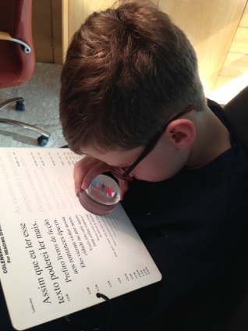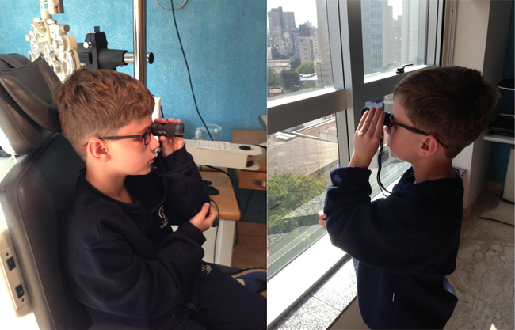  http://www.aao.org/pediatric-center-detail/low-vision-aids  Regional Ocular Health Examinations  Regional optometric examinations are available upon request for up to four students at a time. The optometric examinations include cycloplegic dilation and include evaluation of visual abilities and the health of the eye including the appearance of the eyes, anterior chamber, lens, eye pressures, and refraction to determine the need for glasses and examination of the back of the eye to assess the integrity of the retina. If concerns are noted the student is referred to their private physician for more extensive examination. Regional optometric examinations are provided on a Friday at a location decided upon by the county and include the low vision optometrist and low vision specialist.  Functional Vision Consults and Assessments  We continue to offer functional vision consultations and assessments in the student’s home school or natural environment to address their ability to access age and grade level educational and leisure materials. Areas assessed include but are not limited to color vision, near and distance visual acuities, functional visual perceptual skills, response to magnification and assessment of personal characteristics and environmental factors that may impact functional use of vision. If visual perceptual concerns are suggested during the functional vision assessment, assessment of visual perceptual skills using standardized assessment materials is available with results generated through consultation from MSB occupational therapists. There is no charge for first and second consult visits per student. An hourly or daily rate will be applied on the third visit.  The functional vision consults and assessments are provided from Tuesday through Friday on a day and at a time that it is convenient for the student and staff who work with the student.  The Maryland School for the Blind  Mission  As a statewide resource center, the School provides outreach, educational and residential services for students to reach their fullest potential by preparing them to be as successful, independent, and well-rounded contributing members of their communities as possible.  www.marylandschoolfortheblind.org
Rev: 07-21-2016

