Transition Tuesdays
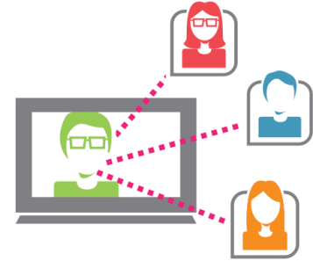
Figure 1 A person on a computer screen connecting with other people.
No need to leave the comfort of your home or office! Participate via your computer with Maryland School for the Blind Outreach as we explore transition in a monthly, informative, free webinar focusing on the transition process and resources available for your student with a visual impairment.

Third Transition Tuesday:
Tuesday, March 21st, 2017
11:30 – 12:30pm
Katelyn Traut, Service Coordination Manager for Kennedy Krieger Institute will present on an overview of the transition process from Infants and Toddlers (Early Intervention Services) to an appropriate preschool program.
Please go to http://www.ustream.tv/channel/maryland-school-for-the-blind

